Tarea 2

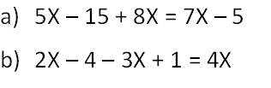

- 5x – 7x + 8x = 15 - 5
6x = 10
X = 10
6

X = 10
6

- 2x - 3x – 4x = 4x
-5x= 3
X=3
-5

X= - 3
5

