**26-5-2014**

|  |
| --- |
| **Alumna: Sierra Aviña Alejandra** | **LEN775** |

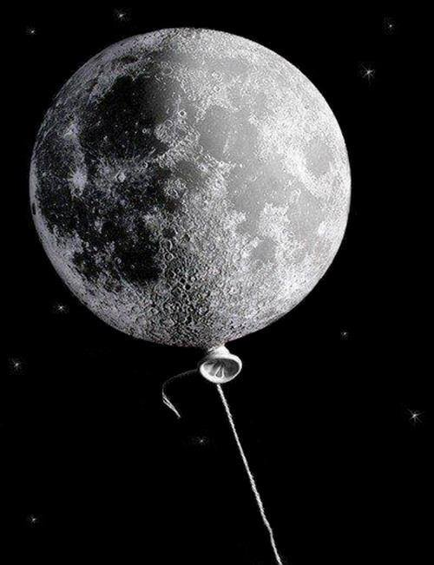

|  |  |
| --- | --- |
| **Remedial matemáticas** | **Tarea inicial** |

**Tarea inicial**

