Nombre: Roberto de Jesús Zúñiga López

Maestro: Andrés Zamudio García

Materia: Lengua extranjera 4

Parcial 3

LAMAR Universidad

4-A BEO

11 de mayo de 2016

Parcial 1
Activity 1
Simple present and its uses:
In English, the present simple, also known as the present simple, 1 is the tense of this (not perfect aspect).
It is one of several times used for the present in English, the other being the present continuous, which has progressive aspect, the present perfect and present perfect continuous.
Expresses truths (Warm air rises - Hot air rises) or stay (Her parents live in Madrid - Her parents live in Madrid) and habitual action, ie, habits or routines in everyday life (I get up late on Sundays - I get up late on a Sunday or I eat a lot of fruit - as much fruit).
It is also used to talk about future events, especially those subject to a schedule, such as arrivals and departures of public transport (The train leaves at nine - The train leaves at nine).
Sources: Wikipedia, slide shire, blueblocnotes.
Text about me in simple present:
I am Roberto de Jesus, I have 16 years old, I live in Guadalajara, I like going out with my family, going to the cinema, on Saturday last week I went to see the movie Creed heart of a champion, I also like family outings, trips to the beach, go to the zoo, listening music, studying, which I do not like are sports, singing, swimming, in a family trips I went with my cousins and uncles to the metropolitan park, the movies with my uncle Hector and my uncle Manuel, my mom and my dad, on another occasion we went to a spa in a family outing three days, the second day went to the park, on the third day we went to the cinema to see the movie pixels, the last time I was invited to the movies we went to see the premiere of the movie Jurassic world in 4D, the last thing I did was go on holiday to the sports complex.
Activity 2:
Continous present and its uses:
It is used to describe actions that are being developed right now:
It is also used to describe actions that are being developed around the time in which it is spoken, though not necessarily in that moment:
I am reading a book.
You are playing football.
It is also used to describe an action that will take place in the near future and which has taken a final decision. In this case, you always have to mention the time in which it will develop the action:
I'm going to London next week (the action is to be developed in the near future and there is a final decision on my part to carry it out).
Another use of the present continuous is to describe actions that have been repeated frequently; in this case, the sentence is accompanied by the word "always" (always):
He is always working (meaning that often works, perhaps even excessively).
Sources: ingles sencillo, aula fácil, curso- ingles.
Text about me in Continous present:
I am Roberto de Jesús, I have 16 years old, I m live in Guadalajara, I like going out with my family, going to the cinema, on Saturday last week I m went to see the movie Creed heart of a champion, I also like family outings, trips to the beach, go to the zoo, listening music, studying, which I do not like are sports, singing, swimming, in a family trips I m went with my cousins and uncles to the metropolitan park, the movies with my uncle Hector and my uncle Manuel, my mom and my dad, on another occasion we are went to a spa in a family outing three days, the second day we are went to the park, on the third day i m went to the cinema to see the movie pixels, the last time I was invited to the movies we are went to see the premiere of the movie Jurassic world in 4D, the last thing I m went on holiday to the sports complex and playing basketball with my friends.
Activity 3:
Simple past and its uses:
The simple past, also known as the simple past, is the verb tense used in the English language to narrate events that occurred at a specific time in the past. It corresponds in its meaning to the simple present perfect tense in Spanish.
Simple past usually have time expressions that refer to the past, such as yesterday, last night / week / month / year / Tuesday, Then, When?, ¿How long ago...?, Aug, in 1997, etc.
When the verb is regular, the statements are constructed using the infinitive and adds them ending ed (or d if the infinitive ends in e.)
Leonardo da Vinci painted the Mona Lisa.
The teacher used a red pencil to correct the exams.
When the verb is irregular, it lies in the second column (listed in the simple past)
I went fishing last weekend.
He bought a car.
When the verb is irregular, it lies in the second column (listed in the simple past).
I didn't go to Salamanca last month.
I didn't do my homework yesterday.
Sources:
Wikipedia, Aprende ingles fácil, aula fácil.
Text about me in simple past:
As a kid I liked that my parents take me to the circus and also going to the park and played with my ball.
My dad bought me drinks and cookies and all were happy.
I really liked playing with dinosaur and learned about how they lived in the past, learned how life evolved on the planet.
I also remember that I liked to eat potatoes, when I went to the movies ate popcorn and soda.
I went every year at Christmas party with my grandparents. He played with my cousins and we had fun bowling.
I also like watching movies of animal themes. But what I liked best was when I gave my gift.
The gift that I really liked was a giant dinosaur that gave me my uncle Hector.
Also playing video games Saturday and Sunday because in the week and spent my time studying these activities.
When I was in the car I saw people passing because I liked to see that people were doing as well as we passed shops.
Activity 4:
Continous present and its uses:
It is used to describe actions that are being developed right now:
It is also used to describe actions that are being developed around the time in which it is spoken, though not necessarily in that moment:
I am reading a book.
You are playing football.
I am studying French.
It is also used to describe an action that will take place in the near future and which has taken a final decision. In this case, you always have to mention the time in which it will develop the action:
I'm going to London next week (the action is to be developed in the near future and there is a final decision on my part to carry it out).
Another use of the present continuous is to describe actions that have been repeated frequently; in this case, the sentence is accompanied by the word "always" (always):
He is always working (meaning that often works, perhaps even excessively).
Sources: ingles sencillo, aula fácil, curso- ingles.
Text about me in Continous present:
I am Roberto de Jesús, I have 16 years old, I m live in Guadalajara, I like going out with my family, going to the cinema, on Saturday last week I m went to see the movie Creed heart of a champion, I also like family outings, trips to the beach, go to the zoo, listening music, studying, which I do not like are sports, singing, swimming, in a family trips I m went with my cousins and uncles to the metropolitan park, the movies with my uncle Hector and my uncle Manuel, my mom and my dad, on another occasion we are went to a spa in a family outing three days, the second day we are went to the park, on the third day i m went to the cinema to see the movie pixels, the last time I was invited to the movies we are went to see the premiere of the movie Jurassic world in 4D, the last thing I m went on holiday to the sports complex and playing basketball with my friends.
Activity 5:
Cover letter:
CURRICULUM VITAE
Personal information
First name(s) / Surname(s) | Roberto de Jesús Zúñiga López
Address | Street Gorrion # 1385 fractionation 8 July
Telephone(s) | 3318444318
E-mail(s) | robertozupero@outlook.com
Nationality | Mexican
Date of birth | 4th August 1999.
Gender | Male
Desired employment | Credit and collection manager. I want to work to overcome personally, get good income, develop and apply my knowledge.

Work experience
Dates | 31st December 2015
Occupation or position held | Credit and collection manager
Main activities and responsibilities | Responsible for customer base Nacional level The main activities carried out in my previous work were as follows: Coordinate the collection  Personnel management credit my charge  Portfolio Turnover review  REPORTING collection  Presentation of results of portfolio each month

Parcial 2
Activity 1:
Interviews about nutrition trends:
Interview 1:
1-How old do you currently have?
A) 12-14
B) 15 to 18
C) 18 to 21
2- what is your gender?
- Male
- Female
3-what degree curses now?
- Intermedia
- Top
- College
4-Do you eat breakfast every day?
A) Yes
B) do not
C) sometimes
5-what do you prefer for breakfast?
A) Cereal (“Corn Flakes", oats, stick of Kellogg’s, etc.)
B) Egg, teosinte, toast or sandwich
C) not just breakfast
6-if you are not in your home, where would you rather go?
A) Sub Way or El Meson
B) a bakery
C) if I'm not in my house, no breakfast
7-what do you prefer to eat a snack?
A) Fruit
B) patty
- Any snack
8-for lunch, what do you prefer?
A) simple salad
B) go to a fast food (Burger King, Mc Donald’s, and Church’s)
C) eat at home (Creole food)
9-For dinner, what do you prefer?
A) Meat or seafood
B) soups
C) salad
10-Do you consume alcoholic beverages?
A) Yes
B) do not
C) sometimes
Interview 2:
1-How old do you currently have?
- 12- 14
- 15- 18
- 18- 21
2- What is your gender?
- Male
- Female
3-¿what degree curses?
- Intermedia
- Top
- College
4-Do you eat breakfast every day?
A) Yes
B) do not
C) sometimes
5-what do you prefer for breakfast?
A) Cereal (“Corn Flakes", oats, stick of Kellogg’s, etc.)
B) Egg, teosinte, toast or sandwich
C) not just breakfast
6-if you are not in your home, where would you rather go?
A) Sub Way or El Meson
B) a bakery
C) if I'm not in my house, no breakfast
7-what do you prefer to eat a snack?
A) Fruit
B) patty
C) Any snack
8-for lunch, what do you prefer?
A) simple salad
B) go to a fast food (Burger King, Mc Donald’s, and Church’s)
C) eat at home (Creole food)
9-For dinner, what do you prefer?
A) Meat
B) soups
C) salad
10-Do you consume alcoholic beverages?
A) Yes
B) do not
C) sometimes
Interview 3:
1-How old do you currently have?
A) 12-14
B) 15-18
C) 18-21
2- What is your gender?
A) Male
B) Female
3-what degree curses now?
A) Intermedia
B) Top
C) College
4-Do you eat breakfast every day?
A) Yes
B) do not
C) sometimes
5-what do you prefer for breakfast?
A) Cereal (“Corn Flakes", oats, stick of Kellogg’s, etc.)
B) Egg, teosinte, toast or sandwich
C) not just breakfast
6-if you are not in your home, where would you rather go?
A) Sub Way or El Meson
B) a bakery
C) if I'm not in my house, no breakfast
7-what do you prefer to eat a snack?
A) Fruit
B) patty
C) Any snack
8-for lunch, what do you prefer?
A) simple salad
B) go to a fast food (Burger King, Mc Donald’s, and Church’s)
C) eat at home (Creole food)
9-For dinner, what do you prefer?
A) Meat
B) soups
C) salad
10-Do you consume alcoholic beverages?
A) Yes
B) do not
C) sometimes
Interview 4:
1-How old do you currently have?
A) 12-14
B) 15 to 18
C) 18 to 21
2- What is your gender?
A) Male
B) Female
3-what degree curses now?
A) Intermedia
B) Top
C) College
4-Do you eat breakfast every day?
A) Yes
B) do not
C) sometimes
5-what do you prefer for breakfast?
A) Cereal (“Corn Flakes", oats, stick of Kellogg’s, etc.)
B) Egg, teosinte, toast or sandwich
C) not just breakfast
6-if you are not in your home, where would you rather go?
A) Sub Way or El Meson
B) a bakery
C) if I'm not in my house, no breakfast
7-what do you prefer to eat a snack?
A) Fruit
B) patty
C) Any snack
8-for lunch, what do you prefer?
A) simple salad
B) go to a fast food (Burger King, Mc Donald’s, and Church’s)
- eat at home (Creole food)
9-For dinner, what do you prefer?
A) Meat
B) soups
C) salad
10-Do you consume alcoholic beverages?
A) Yes
B) do not
C) sometimes
Interview 5:
1-How old do you currently have?
A) 12-14
B) 15 to 18
C) 18 to 21
2- What is your gender?
A) Male
B) Female
3-what degree curses now?
A) Intermedia
B) Top
C) College
4-Do you eat breakfast every day?
A) Yes
B) do not
C) sometimes
5-what do you prefer for breakfast?
A) Cereal (“Corn Flakes", oats, stick of Kellogg’s, etc.)
B) Egg, teosinte, toast
C) not just breakfast
6-if you are not in your home, where would you rather go?
A) Sub Way
B) a bakery
C) if I'm not in my house, no breakfast
7-what do you prefer to eat a snack?
A) Fruit
B) patty
C) Any snack
8-for lunch, what do you prefer?
A) simple salad
B) go to a fast food (Burger King, Mc Donald’s, and Church’s)
C) eat at home (Creole food)
9-For dinner, what do you prefer?
A) Meat
B) soups
C) salad
10-Do you consume alcoholic beverages?
A) Yes
B) do not
C) sometimes
Interview 6:
1-How old do you currently have?
A) 12-14
B) 15 to 18
C) 18 to 21
2- What is your gender?
A) Male
B) Female
3-what degree curses now?
A) Intermedia
B) Top
C) College
4-Do you eat breakfast every day?
A) Yes
B) do not
C) sometimes
5-what do you prefer for breakfast?
A) Cereal (“Corn Flakes", oats, stick of Kellogg’s, etc.)
B) Egg, teosinte, toast or sandwich
C) not just breakfast
6-if you are not in your home, where would you rather go?
A) Sub Way or El Meson
B) a bakery
C) if I'm not in my house, no breakfast
7-what do you prefer to eat a snack?
A) Fruit
B) patty
C) Any snack
8-for lunch, what do you prefer?
A) simple salad
B) go to a fast food (Burger King, Mc Donald’s, and Church’s)
C) eat at home (Creole food)
9-For dinner, what do you prefer?
A) Meat
B) soups
C) salad
10-Do you consume alcoholic beverages?
A) Yes
B) do not
C) sometimes
Interview 7:
1-How old do you currently have?
A) 12-14
B) 15 to 18
C) 18 to 21
2- What is your gender?
A) Male
B) Female
3-what degree curses now?
A) Intermedia
B) Top
C) College
4-Do you eat breakfast every day?
A) Yes
B) do not
C) sometimes
5-what do you prefer for breakfast?
A) Cereal (“Corn Flakes", oats, stick of Kellogg’s, etc.)
B) Egg, teosinte, toast or sandwich
C) not just breakfast
6-if you are not in your home, where would you rather go?
A) Sub Way or El Meson
B) a bakery
C) if I'm not in my house, no breakfast
7-what do you prefer to eat a snack?
A) Fruit
B) patty
C) Any snack
8-for lunch, what do you prefer?
A) simple salad
B) go to a fast food (Burger King, Mc Donald’s, and Church’s)
- eat at home (Creole food)
9-For dinner, what do you prefer?
A) Meat
B) soups
C) salad
10-Do you consume alcoholic beverages?
A) Yes
B) do not
C) sometimes
Interview 8:
1-How old do you currently have?
A) 12-14
B) 15 to 18
C) 18 to 21
2- What is your gender?
A) Male
B) Female
3-what degree curses now?
A) Intermedia
B) Top
C) College
4-Do you eat breakfast every day?
A) Yes
B) do not
C) sometimes
5-what do you prefer for breakfast?
A) Cereal (“Corn Flakes", oats, stick of Kellogg’s, etc.)
B) Egg, teosinte, toast or sandwich
C) not just breakfast
6-if you are not in your home, where would you rather go?
A) Sub Way
B) a bakery
C) if I'm not in my house, no breakfast
7-what do you prefer to eat a snack?
A) Fruit
B) patty
C) Any snack
8-for lunch, what do you prefer?
A) simple salad
B) go to a fast food (Burger King, Mc Donald’s, and Church’s)
- eat at home (Creole food)
9-For dinner, what do you prefer?
A) Meat
B) soups
C) salad
10-Do you consume alcoholic beverages?
A) Yes
B) do not
C) sometimes
Conclusion about that:
Through interviews I met the eating habits of several people and I saw that all have different eating habits, also note that dietary habits depend on sex, age.
Common results:
1-A) 4 times
2- A) 5 times
3- C) 5 times
4- A) 6 times
5- B) 4 times
6-C) 4 times
7-C) 4 times
8-B) 4 times
9-A) 5 times
10-B) 7 times
Activity 2:
Main ideas:
Identify the differences between what our soul tells us and what we feel in our heart.
Listen to what advises the heart being positive.
Text report Khalil Gibran in which he expresses his deepest feelings of youth:
The text talks about the soul Khalil Gibran spoke and taught him to love what the people loathed and protect what denigrated, showed that love is proud not only of a friend but also the beloved, this text teaches us to love our neighbors and to respect with all its physical and psychological defects, of us came out a light and illuminates our path, eternity alone saves the love, because love is like eternity, the state supreme soul is to obey even against what is revealed. And the lowest state of mind is rebelling against what the soul obeys us.
Activity 3:
Why I chose this topic:
I chose this topic because I would like to learn about the lifestyle of snakes, to know how they can find their prey, the way that attack, as they do to achieve. It also mentions some of the most dangerous species of snakes, sizes they have and where they live.
Information about snakes:
Snakes (Serpentes) or ofidios (Ophidia) are a suborder of sauropsids (reptiles) diapsids belonging to the order Anura, superorder lepidosaurs, characterized by the absence of legs (the python keeps tiny limbs fruit of their evolutionary process) and the body very elongated. They originated in the Cretaceous period.
The snakes are characterized by the absence of limbs and elongated body. Some have poisonous bites, such as cobras and vipers, which they use to kill their prey before eating. Other snakes, such as boas and pythons, kill their prey by constricción.Se recognize more than 450 genera and 3460 species. It is believed that snakes derived from some kind of lizard, but the specifics of its origin are unclear. Snake skin is covered with scales. Most snakes use the ventral scales to move, gripping surfaces with them.
Images of snakes:
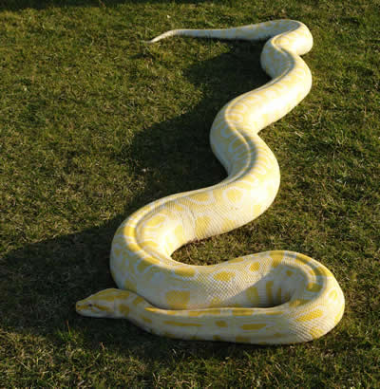
Reticulated python
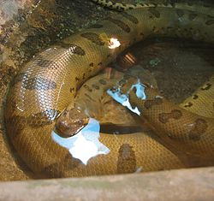
Anaconda
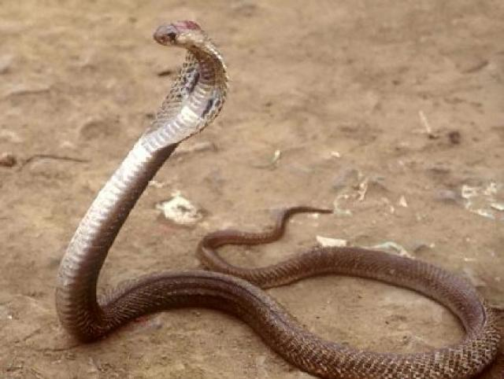
King Cobra
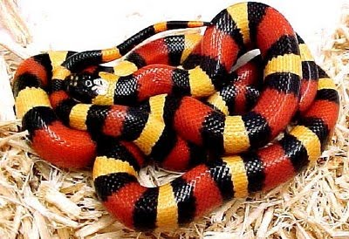
Coralillo
Activity 4:
What is the movie about:
The film is about Rocky Balboa, a failed boxer who live in poverty and that comes the opportunity to change all fight against world heavyweight champion Apollo Creed, with the help of Mickey coach trains hard to get the opportunity of a lifetime and the message that leaves me the film is:
That if we trust ourselves without giving may be able to accomplish everything we set and more, also it teaches us to keep trying until we achieve what we set. And despite the obstacles and though life put limits you can move forward, if we want to decide.
Activity 5:
Why did I choose this topic:
I chose this topic because I want to know more about these fish, as they attack their prey, as they defend, sizes and weights reaching, places where they live, what their power, his attacks on humans, since as they are on the planet, also will show them pictures of sharks.
Development of the topic:
The selacimorfos (Selachimorpha, the σελαχος Greek, selachos, shark, and μορφή, morphe, form) are a superorder chondrichthyan (cartilaginous fish) commonly known by the name of sharks, also called dogfish. Some large sharks such as white and bull, among other things, are sometimes known by the name of sharks. They are characterized by large predators. Sharks include small deep-sea species, to the whale shark, the largest fish, which is believe can grow to a length of 18 m and feeds only on plankton. The bull shark can move to fresh water and some shark attacks have occurred in rivers. Some of the larger species, especially the mako shark and the great white shark, are endotherms partial able to partially maintain their body temperature above which has the aquatic environment in which they live.
Of the more than 375 shark species found in the world's oceans, the species responsible for most unprovoked attacks on humans are great white shark, tiger shark, bull shark and Carcharhinus leucas.
Poem about the them:
They live in the sea
When they attack no one can escape,
Do instinctively,
Others are different,
Million years evolving
They have become what they are now
Some attack by defense
Others analyze prone situation
Then cause a commotion
Shortly before the action.

Pictures of sharks:
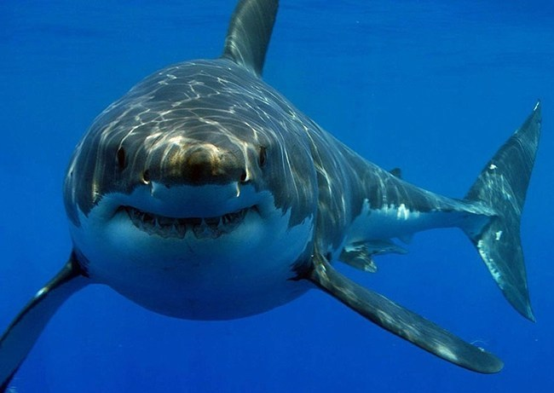
Great white Shark
Length: 5-9 meters
Weight: 4 tones
Eats: seals, dolphins, turtles, and small whales
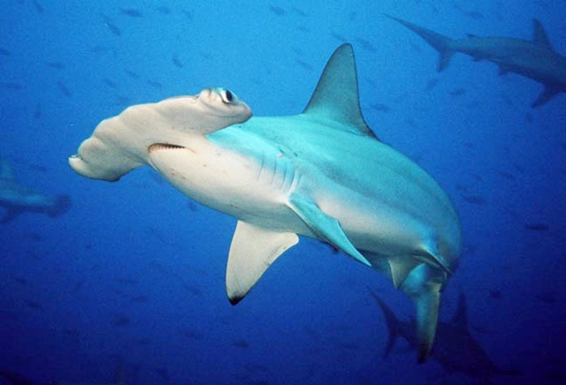
Hammer head shark
Length: 6 meters
Weight: 1-2 tones
Eats: birds, crabs and octopus.
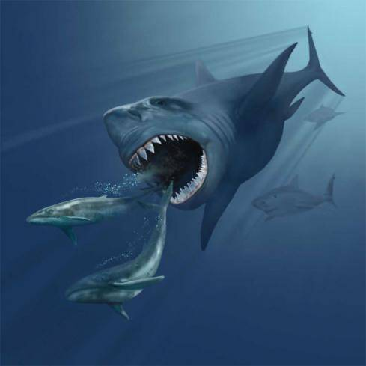
Megalodon
Length: 40-115 meters
Weight: 100-200 tones
Eats: colosal squids and whales
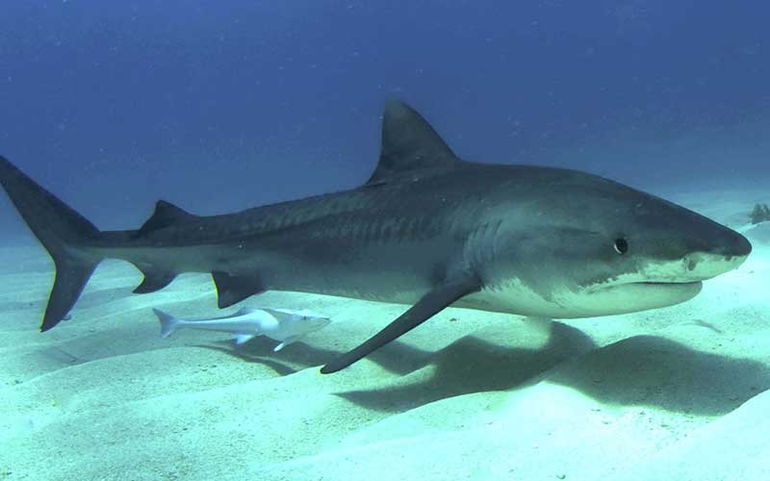
Tiger shark
Lenght: 3.3- 7.2 meters
Weight: 700 Kilograms
Eats: fish, molluscs, crustaceans, turtles and seabirds and mammals such as the dugong
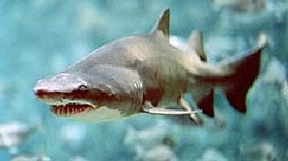
Bull Shark
Lenght: 3.5 meters
Weight: 300 Kilograms
Eats: Fish, stingrays, and smaller sharks

Parcial 3
Activity 1:
Plan “C”:
Recycle the trash
Evaluation plan “C”:
10
Conclusion:
I think this plan is the best because reducing the production of waste in the house help to keep our city clean and environment, also care areas that are contaminated, for example, the ocean, forests and jungles, if we throw garbage instead of recycle forest areas, rivers, lakes and oceans is polluting finished and all the flora and fauna they will die and all these places will become uninhabitable for decades or even centuries but we can prevent that from happening reducing waste production, por example, use cans to make ornaments or candleholder and carry paper and cardboard recycling center.
Activity 2:
Problems of daily living
Problem:
Unemployment
Reason I chose:
I chose it because it is one of the biggest problems of human society and generated poverty and inequality among people
Which solution you propose?
Generate more jobs
Steps to achieve this:
Empowering people
Open business opportunities
Problem:
Domestic violence
Reason I chose:
I chose this issue because it affects physical and mental way to family members
Which solution you propose?
Resolve family conflicts
Steps to achieve this:
Create laws protecting the family
Family support programs
Create schools for parents and children to help them find solutions to the problems they may have
Problem:
Lack of family communication
Reason I chose:
I chose it because communication in a family is important to avoid conflicts
Which solution you propose?
That family members express what they think everyone else to know your opinion
Steps to achieve this:
Talk about problems
Find solutions between the conflicting parts
Reach an agreement
Conclusion:
There are many problems in our daily lives such as unemployment, lack of communication, domestic violence and many other problems that need a different solution for each, only keeping the family together we can solve it no matter what comes our perhaps not today or tomorrow but when the situation arises nothing prevent us find a solution to virtually any problem, not only these, but also to all those problems to us they arises if all cooperated find the solution.
Activity 3:
Assertive techniques
Situation in which I lost my temper:
It happened that made a team working between partner and I and my partner rightful print the job on a subject that was the company, but the day we had to deliver the work my partner did not lead him and seis: I can not believe that are you forgot, that work was for today and bother me.
How you will manage again:
For this does not happen again, I must ask one day before handing the job to see if it's going to take, I must ask if you had a problem, I must not lose patience and I understand their motives

Conclusion:
This semester I learned what it is the continuous past and its uses, which is the past participle, present continuous, present participle, did a cover letter to apply for work and also prepare a survey on eating habits, investigate issues that I like the development were issues about snakes and sharks also explain a situation where I lost my patience and a way to solve it So it will not happen again again, at the same time I learned to express myself in English, in the case of looking for a job I realized that it is important to know another language for better opportunities in my life.
I think this will help me in my future.

