2017
Adrian Paul Mata
Ingles
19-5-2017
Assertiveness
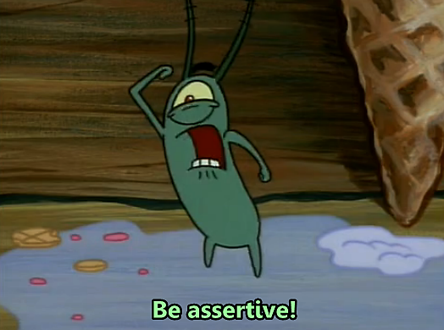
I have always considered myself like a peaceful person, so it’s complicated that I lose the control.
I took about two hours trying to remember one moment where I lost my temperament, but honestly I can’t remember one.
Possibly this moment not yet arrived, even so considered that article is very interesting and one day can serve me.

