Letter to my mother.
Mom, I want to tell you that you are very special to me, you are a fundamental part of my life because you are always for me, to take care of me, to advise me, to love me.
I do not know what I would do without you because you are the best mom anyone can have, thanks for being so good to me, even thanks for scolding because I know they are for my good.
We have many good moments together, but one of the ones that I like most are when we went to Puebla together, it was a very good trip between mother and daughter and I thank you for being there for me.
I love you with all my heart.
Your daughter.
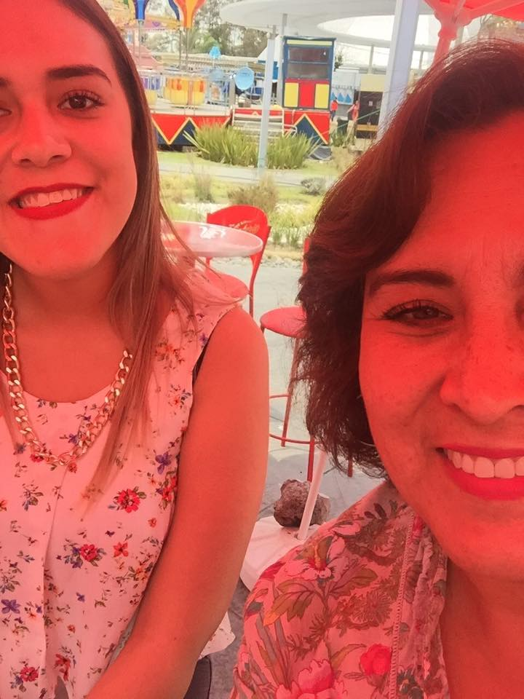

The reaction.
I just gave the letter to my mom, and she read it in front of me and then hugged me and told me that she loved me and that she would always be for me.

