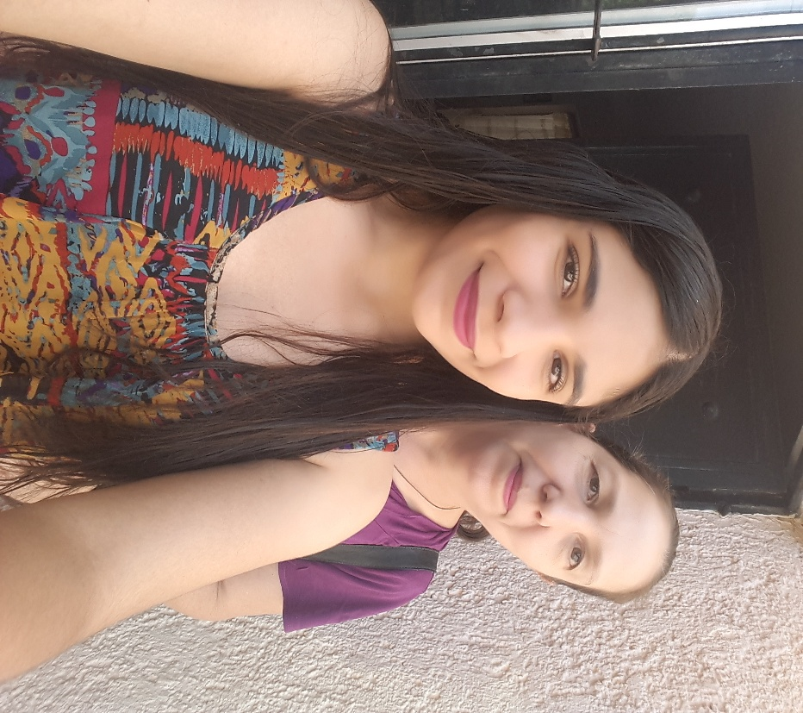
Mom:
In this letter I want to thank you for everything you've given you have always been there for me when I need you and you always know how to calm me down and you have a solution for everything, I really do not know what I would do without you, you are my greatest support and I love you with everything My heart, I know sometimes because I'm not the best daughter but tried to be ajajja and took advantage that you are reading this to ask your forgiveness if any of you are hurt by something I said or did you know that I would never do it with that intention, you are the Best woman I know tender, tender very patient and noble and you have many more virtues mami but I do not have the time to say them, I want you to know that even though the years go by and you feel that I leave, that will never happen thanks for being the best mom in the world I love you, never change your way to be mommy because that's what makes you incredible, you're an amazing mother, wife, sister, sister, I have nothing left but to try to thank you for each and every one of those moments that we have. Roast together I'll never forget all those recipes we've prepared together are the best this is not enough to express everything I think but I try to love you Mommy
My mom reacted very lovingly to me, gave me a kiss and hugged me hard, and told me that we will always be together, and she told me that she was the luckiest mom to have me.

