Nombre: Roberto de Jesús Zúñiga López

Maestro: Andrés Zamudio García

Materia: Lengua extranjera 4

LAMAR Universidad

4-A BEO

13 de abril de 2016

Why did I choose this topic:
I chose this topic because I want to know more about these fish, as they attack their prey, as they defend, sizes and weights reaching, places where they live, what their power, his attacks on humans, since as they are on the planet, also will show them pictures of sharks.

Development of the topic:
The selacimorfos (Selachimorpha, the σελαχος Greek, selachos, shark, and μορφή, morphe, form) are a superorder chondrichthyan (cartilaginous fish) commonly known by the name of sharks, also called dogfish. Some large sharks such as white and bull, among other things, are sometimes known by the name of sharks. They are characterized by large predators. Sharks include small deep-sea species, to the whale shark, the largest fish, which is believe can grow to a length of 18 m and feeds only on plankton. The bull shark can move to fresh water and some shark attacks have occurred in rivers. Some of the larger species, especially the mako shark and the great white shark, are endotherms partial able to partially maintain their body temperature above which has the aquatic environment in which they live.
Of the more than 375 shark species found in the world's oceans, the species responsible for most unprovoked attacks on humans are great white shark, tiger shark, bull shark and Carcharhinus leucas.
Poem about the them:
They live in the sea
When they attack no one can escape,
Do instinctively,
Others are different,
Million years evolving
They have become what they are now
Some attack by defense
Others analyze prone situation
Then cause a commotion
Shortly before the action.

Pictures of sharks:
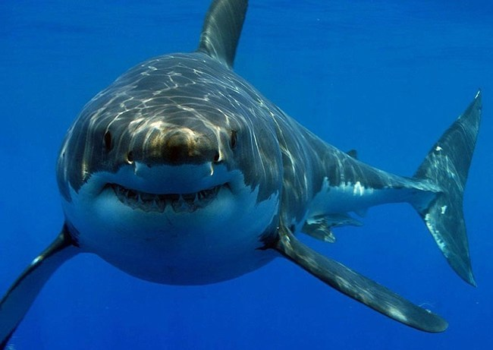
Great white Shark
Length: 5-9 meters
Weight: 4 tones
Eats: seals, dolphins, turtles, and small whales
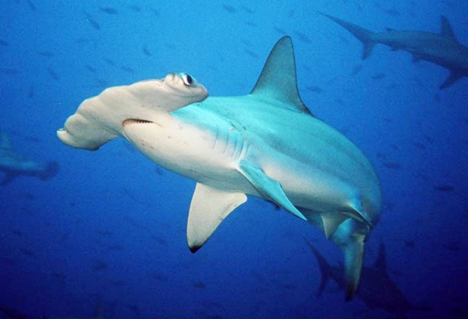
Hammer head shark
Length: 6 meters
Weight: 1-2 tones
Eats: birds and octopus.
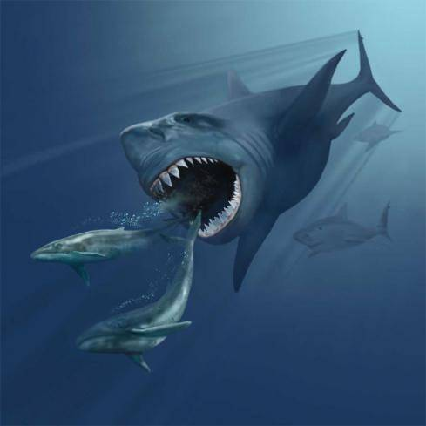
Megalodon
Length: 40-115 meters
Weight: 100-200 tones
Eats: colosal squids and whales
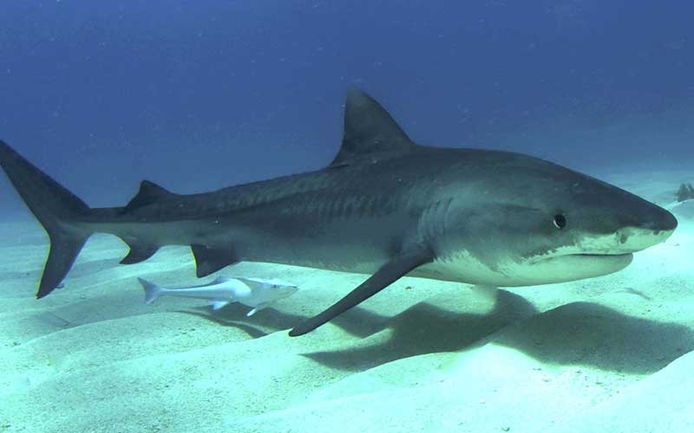
Tiger shark
Lenght: 3.3- 7.2 meters
Weight: 700 Kilograms
Eats: fish, molluscs, crustaceans, turtles and seabirds and mammals such as the dugong
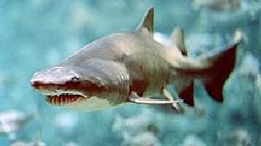
Bull Shark
Lenght: 3.5 meters
Weight: 300 Kilograms
Eats: Fish, stingrays, and smaller sharks

