HUMBERTO ALEXIS DEL TORO GONZALEZ 4-A UNIVERSIDAD LAMAR LENGUA EXTRANJERA 4
FECHA: 23 DE MARZO DEL 2017 BEO 4254
It seems to me that the movie I saw called the godfather is one of the most bloody movies that I do not believe but I think it is one of the movies with more work and history behind a hard work filming in which you noticed Every review of the libretto in the time that this film was taken was not born but for that moment cave emphasize that it was and is of the best films that the American ine.
But what this movie is about is an old man who is one of the richest men in New York with a beautiful family of four or five people I do not remember very well.
Vito would be a King, an emperor or in animal lands a Leon, a leader of the herd, a patriarch, that infuses in its enemies fear and hatred but for own and strangers imposes a respect until arriving at levels of affection. Connie, shows us an introduction of the characters and the personality of its leader, its children Santino "Sonny" (James Caan), Fredo, Tom Hagen, the adviser who wants Don Corleone like a father and the minor son, Business and war hero Michael Corleone (Al Paccino).
It also introduces us into the traditional structures of the Italian Catholic family (very similar in Mexico, Spain and Ireland) to merge with the American life of the children of those who left Sicily and the great Bota del Mediterraneo for a better life in America. Represented by Vito and his sons respectively.
After that we see how Don Corleone, through Tom Hagen (Robert Duval), gets his godson Johnny Fontane to get a role of a reluctant producer to hire him and the way in which he is forced to accept.
Don Corleone receives the proposal of Virgil Sollozzo to be inserted in a new business that promises more profits than the game and the drink and it grows to step gigantic: the drugs. In spite of the opinion of his counselor and his children, the father decides not to enter into that business, considering that it would considerably mess up business and the current environment, despite not agreeing, the children and subordinates respect and defend their wishes.
It is then that "The Don" is the victim of an attack that threatens his life, his children and allies must take refuge and plan the following movements and send surveillance to the hospital, Michael who is limited to minor things without compromise, save the life to his Father of probable attacks of the Mafia Tattaglia and of the police who is paid by Sollozzo.
Michael only comes on the reflex of being part of the "family" and seek revenge for his father and the safety of his family so the orchestra an attempt that works to kill Sollozzo and the captain of police McCluskey, so he must Escape to Sicily leaving his girlfriend Kay.
Santino "Sonny" is in charge and cleans potential traitors and declares war on the Tattaglia while his father recovers. He already heads the family and attends to problems like that of his brother-in-law Carlo who mistreats his sister Connie.
While all this happens, in Sicily Michael knows and enters the land of his parents and stops in the town of Corleone, where is his father and there in a procession meets Apollonia, a beautiful little village of which later The traditional way: asking permission from the father (Speaking about his status in Cossa Nostra), dating her with chaperonas and marrying in the Catholic rite, removing her virginity on the wedding night.
Back in New York Sonny and the family are more armed than ever, Don Vito is already at home and supports the actions of his son, who unfortunately dies riddled in an ambush when he goes to kill his brother-in-law Carlo, after that in An attempt to assassinate Michael, Apollonia dies when exploding his car, Michael returns to USA.
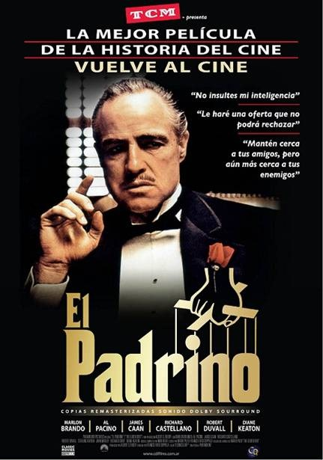
Don Vito, knowing about the death of his son, agrees to peace with the families, especiallywith the Tattaglia, realizing that the Barzini are behind these deaths.Michael returns to take over business, prepares a war, before that he returns with his old girlfriend Kay and has children, Don Vito is his advisor and Michael also seeks to establish business in Las Vegas, trying to buy the Moe Greene casino, Without success first. Subsequently comes the death of Vito Corleone, in a rare way for those of his kind, in peace and in the vicinity of his grandson grandson Anthony with whom he played at that time, that advancing to the scenes in my taste a Of the most beautiful aesthetically speaking.

