2017

Adrian Paul Mata

Ingles

24-3-2017

THE CLOCKWORK ORANGE

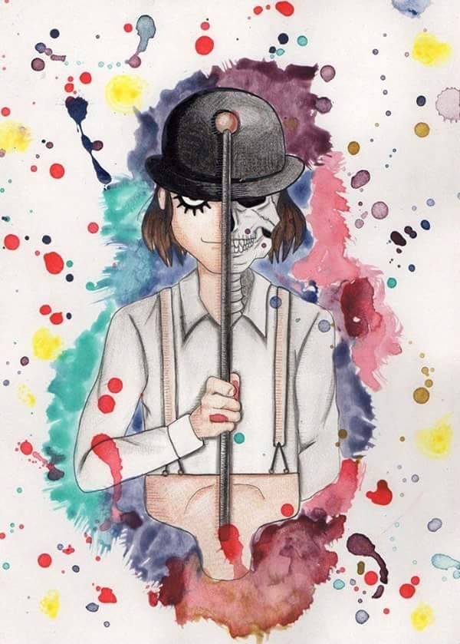

A Clockwork Orange is a very cool film, based perfectly, except for the lack of chapter 21 on Anthony Burgess's novel

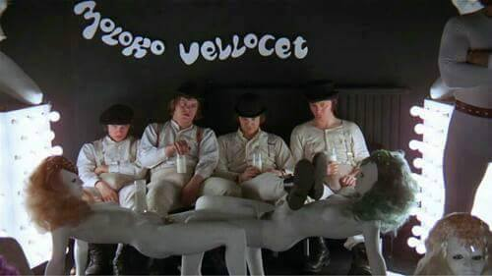In the film Alex DeLarge is the leader of his "droogs" (friends), Georgie, Dim and Pete. This group practices crimes involving “ultra-violent” acts by themselves. One night, after getting intoxicated in the milk bar “Korova” While planning their next night mischief. First beat an old drunk lying in the street, after fight with a rival gang led by Billyboy. Finally invade a writer's house, to beat him and rape his wife while Alex sings I'm Singing in the Rain. “

Alex spends his time devoting himself to ultra-violent “and committing robberies or occasional assaults to finance his lifestyle. Alex's passion is classical music, especially Ludwig van Beethoven.

After a discussion concerning the leadership of the band, a fight takes place between its members. Finally, Alex manages to maintain control, although the others remain dissatisfied. Alex is deceived by his friends to carry out a robbery in the house of an old woman, where he was betrayed and left to be taken to prison by the police. He is sentenced to 14 years in prison.

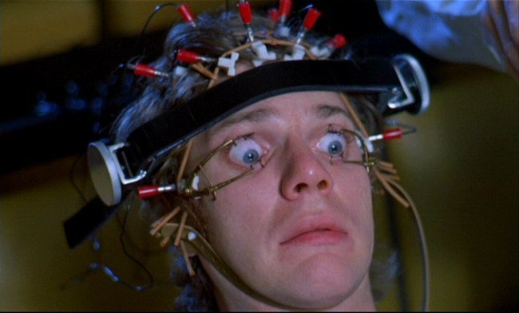Two years into the sentence, Alex eagerly takes up an offer to be a test subject for the Minister of the Interior's new Ludovico technique, an experimental aversion therapy for rehabilitating criminals within two weeks. Alex is strapped to a chair, injected with drugs, and forced to watch films of sex and violence with his eyes propped open. Alex becomes nauseated by the films, and then recognizes the films are set to music of his favorite composer,

Alex asks for the end of the treatment. Two weeks later, the minister demonstrates the rehabilitation of Alex to a meeting of officials. Alex is unable to fight an actor who insults him and attacks him, and becomes sick to see a naked woman. The prison chaplain complains that Alex has been stripped of his free will, leaving his humanity but the minister says Ludovico's technique will reduce crime and relieve overcrowding in prisons.

He is left without the ability to defend himself, and is also evicted by his parents, who do not want him at home because they have rented their room to a guest, discarded his stereo and treasures and apparently killed his pet snake.

Discouraged Alex wanders around London. Soon he meets old victims and two policemen, his old "droog" and rival, Dim and Billyboy, who recognize him, beat him and almost drown him.

Alex wanders through the woods to the writer's house. The writer lets him in before discovering his identity; then drug Alex and try to make him commit suicide by making him listen loudly Beethoven's Ninth Symphony but he survives.

Alex wakes up in a hospital with broken bones. While being given a series of psychological tests, The Minister arrives and apologizes to Alex. He offers to take care of Alex and get him a job in return for his cooperation with his election campaign and public.

This film is a criticism to the psychology and the morality of the human beings, and it is expressed that there is no pure evil or pure goodness, through Alex DeLarge

