50 Shades of Gray

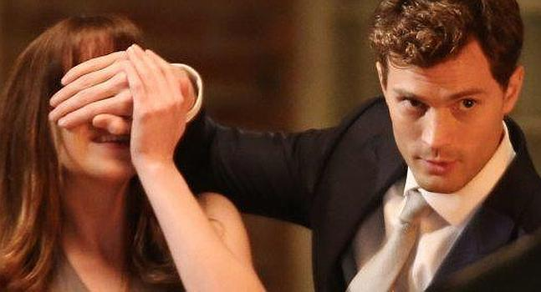

Is the story of a girl who has a 21-year-old college student in Washington who lives with her best friend, Katherine, who writes for her college newspaper. Due to a cold, Katherine persuades Ana to take her place in the interview that would make Christian Gray, a young and successful businessman. Ana is immediately attracted to him, but also finds him intimidating. As a result the interview does not go quite well and leaves Gray a bad impression - or at least that's what she believes. Ana tries to console herself with the idea that she most likely will not see him again. However, he is surprised when Gray appears at the hardware store where he works. During the purchase of several items, including cable ties and strings, Ana informs Gray that Katherine wants photographs of him for the article. Gray gives Ana his phone number, which makes Ana think she likes him. Katherine presses Ana to call Gray and organize a photo shoot with her friend the photographer.

The next day, Jose, Katherine and Ana arrive at the hotel where Gray is staying, the photo shoot takes place and Gray invites Ana to have a coffee. They both talk about their lives and Gray asks Ana if she's dating anyone. Ana responds that she is not seeing anyone, then Gray asks about her family. During the conversation, Ana learns that Gray is single, but that he is not the kind of man with "flowers and hearts." This intrigues Ana, especially after she rescues her from the trajectory of a cyclist who was about to run over her. However, Ana believes that she is not attractive enough for Gray, as her friend is.

After completing her exams Ana receives a packet of Gray, which contains her favorite books. That night Ana is going to drink with her friends, ends up getting drunk and marking Gray on the phone to ask her why she sent him the books, but he does not respond and informs her that she is going to pick her up because of her drunkenness. Ana agrees that Gray takes her home, but first discovers that her friend Katherine has been flirting with Gray's brother. Waking up the next morning, Ana is in Gray's hotel room, who rebukes her for not caring properly. Gray then reveals that he would like to have sex with her, then mention that he should fill out the paperwork before something happens.

Anastasia goes on her date with Gray, who pilots his helicopter, to his apartment in Seattle. Once there, Gray insists that he sign a confidentiality agreement that prohibits him from talking about what they do together, which Ana agrees to sign. She also mentions other documents, but first she takes her to a room full of sex toys and other equipment. There Gray informs him that the second contract will be one of domination and submission and that there will be no romantic relationship, just a sexual relationship. The contract even prohibits Ana from touching Gray or making eye contact with him. When Gray is explaining this to her, Ana confesses that she is a virgin and he agrees to take her virginity without forcing her to sign the contract and then have sex.

The next morning, Ana and Gray have once again sexual relations, only to be interrupted by Gray's mother, who arrives moments after their sexual encounter. His mother is surprised to see Ana there, since she assumed that Gray was homosexual because he had never seen him with a woman. Later Christian takes Anastasia to lunch, revealing that she lost her virginity at age fifteen with one of her mother's friends and that her previous dominant / submissive "relationships" failed because of the incompatibility. Gray takes Ana to her home, where she admits to Katherine that she and Gray have had sex.
In the following days, Ana receives several packets of Gray. These include a Mac so that the two can communicate through emails, since Ana has never had a personal computer before. Ana and Gray exchange emails, where Ana mocks him and tells him that there are several parties in the contract that he does not want to accept. Ana later meets with Gray to discuss the contract, and is overwhelmed by the fact of maintaining an exclusively sexual relationship with Gray that is not romantic.
It's a movie that caught my attention, it's a bit strange in my opinion. Has a score of 5 which is very worse rating. It depends on whether the person could recommend it or not

