MARIA JOSE DE SANTIAGO ARRIOLA

PLAFORMA INGLES

4B

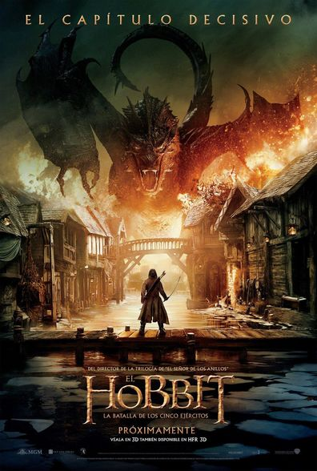

Die the dragon that lived under the mountain, and that's when the team from Shield of Oak they get home , one of the main characters is Thorin the king under the mountain.

The plot is to come, because the war begins elves, peasants, orcs, dwarfs they fight each other, but for different purposes elves and peasants for the treasure of the mountain, and orcs for the death of the King.

On the other hand the dwarves blinded by greed and more the King, they lock themselves in the mountain without fighting. But for a hobbit called bilbo the King comes into reason and goes out to fight.

The King dies along with his enemy Azoc .

