Movie report
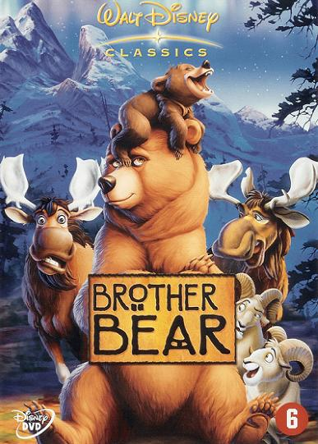

I want to talk about this movie because I really like it because it remebers me my childhood so it`s very important for me.
In the movie were three brothers they hunted animals to eat them but one of the brothers ( Kenai) didn´t like bears so he always wanted to kill them, one day his brother (Circa) was in trouble with a bear ther were on a big piece of ice and hi kill himself then Kenai wanted to take revenge by killing the bear he followed the bear until he kill it, but the thing he didn´t know was that te bear was a mom of a little bear (Koda).
He magically changed into a bear himself as punishment with the terrible action he done, then Kenai met Koda and the spend a lot of time together because Kenai wanted to go to a magical place where he can return to a human instead of being a bear.
At the end Kenai take care of Koda like a little brother.
