Movie report
2017
Jazmin Paola Llamas Rojas 4 B
Lengua Extranjera
25/03/2017
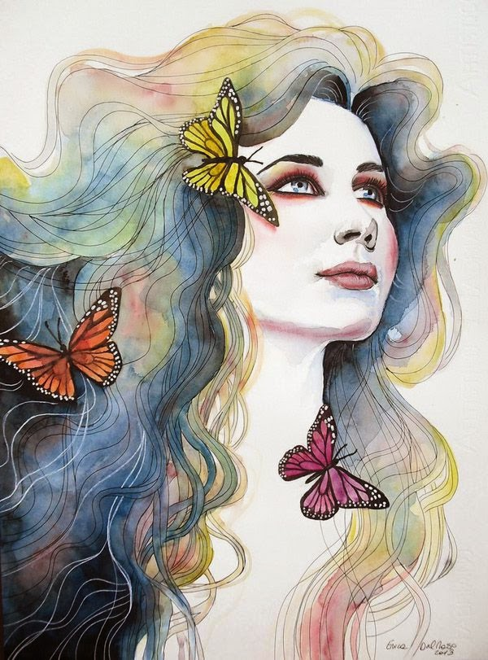
10 things I hate about you.
This movie is one of my favorites, it’s very old, but is so funny and romantic, it’s about of one boy that is interested on a girl, but that girl has a parent very jealous and protective, he put a rule that if her sister very antisocial don´t go out she neither. So that boy created a plan. He goes with a gay very dangerous willing to help for money. That gay invite the sister to go out and with the time the romance become to go out, she and he start to fell in love but then she find out, that he only invite her for money.
I like it very much not only because he is very handsome but also because is very interesting and different of others romantic movies

