Fatima Avalos Rojas

lamar

Lengua extranjera

MENU

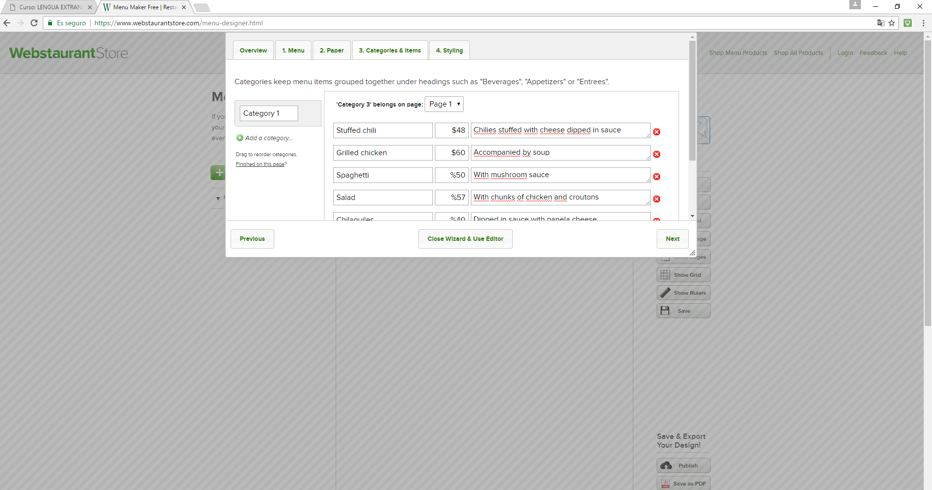

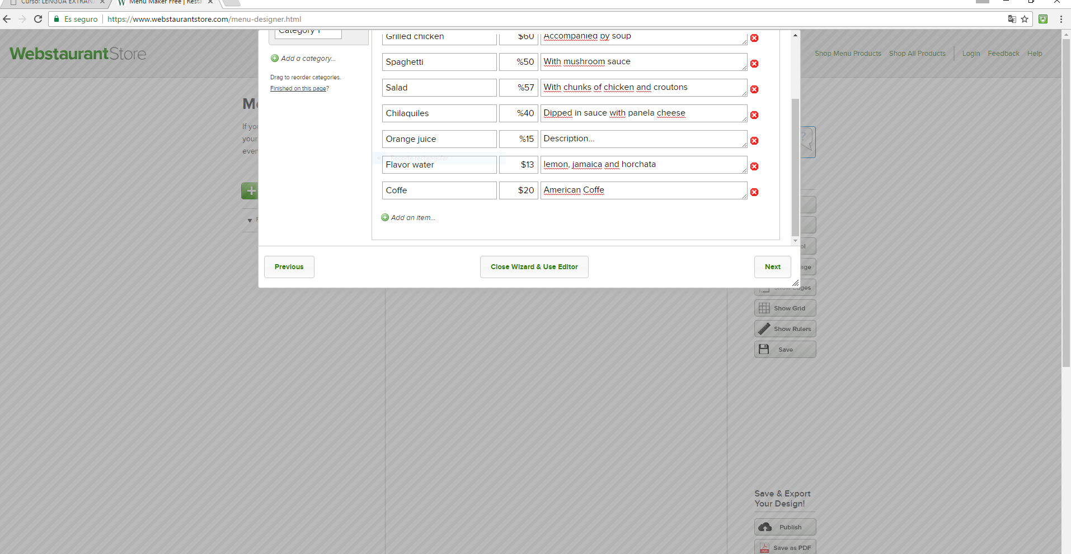

Teacher. I can´t put the data in the sheet of my menú.