universidad lamar
Actividad 3
Lengua Extranjera IV
Student: Valeria Noemi López Correa
Teacher: Norma Elizabeth Barajas Román

PARCIAL ll

The One and Only
This is a coffee shop, minimalist, small and hipster.
We are aimed to millennials, which is why our concepts are so new.
We are 2 baristas, 3 waiters/ waitresses, one janitor, a gerent and the owner will be constantly checking the location.
We are located at Chapu, just in front Quick Learning.
We will have special discounts for students.

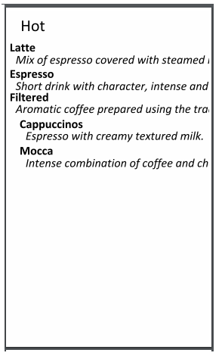
Menu

