MARISCOS EL COMPITA
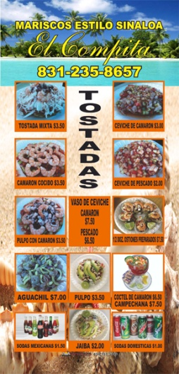
Number of employees: 10
Is a small seafood restaurant with pure quality produce
