Nombre: Roberto de Jesús Zúñiga López

Maestro: Andrés Zamudio García

Materia: Lengua extranjera 4

LAMAR Universidad

4-A BEO

1 de abril de 2016

Why I chose this topic:
I chose this topic because I would like to learn about the lifestyle of snakes, to know how they can find their prey, the way that attack, as they do to achieve. It also mentions some of the most dangerous species of snakes, sizes they have and where they live.
Information about snakes:
Snakes (Serpentes) or ofidios (Ophidia) are a suborder of sauropsids (reptiles) diapsids belonging to the order Anura, superorder lepidosaurs, characterized by the absence of legs (the python keeps tiny limbs fruit of their evolutionary process) and the body very elongated. They originated in the Cretaceous period.
The snakes are characterized by the absence of limbs and elongated body. Some have poisonous bites, such as cobras and vipers, which they use to kill their prey before eating. Other snakes, such as boas and pythons, kill their prey by constricción.Se recognize more than 450 genera and 3460 species. It is believed that snakes derived from some kind of lizard, but the specifics of its origin are unclear. Snake skin is covered with scales. Most snakes use the ventral scales to move, gripping surfaces with them.
Images of snakes:
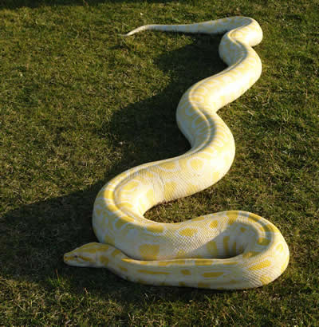
reticulated python
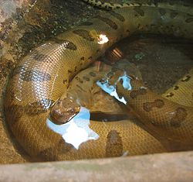
Anaconda

  - 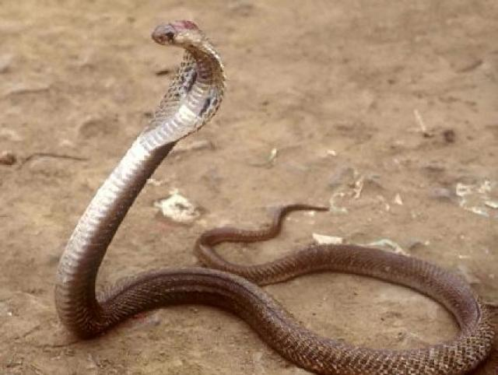
King Cobra
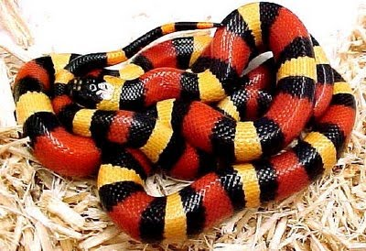
Coralillo

