Quiz Results: Question Tags

You got 36 / 36 questions correct.

Your grade: 100%

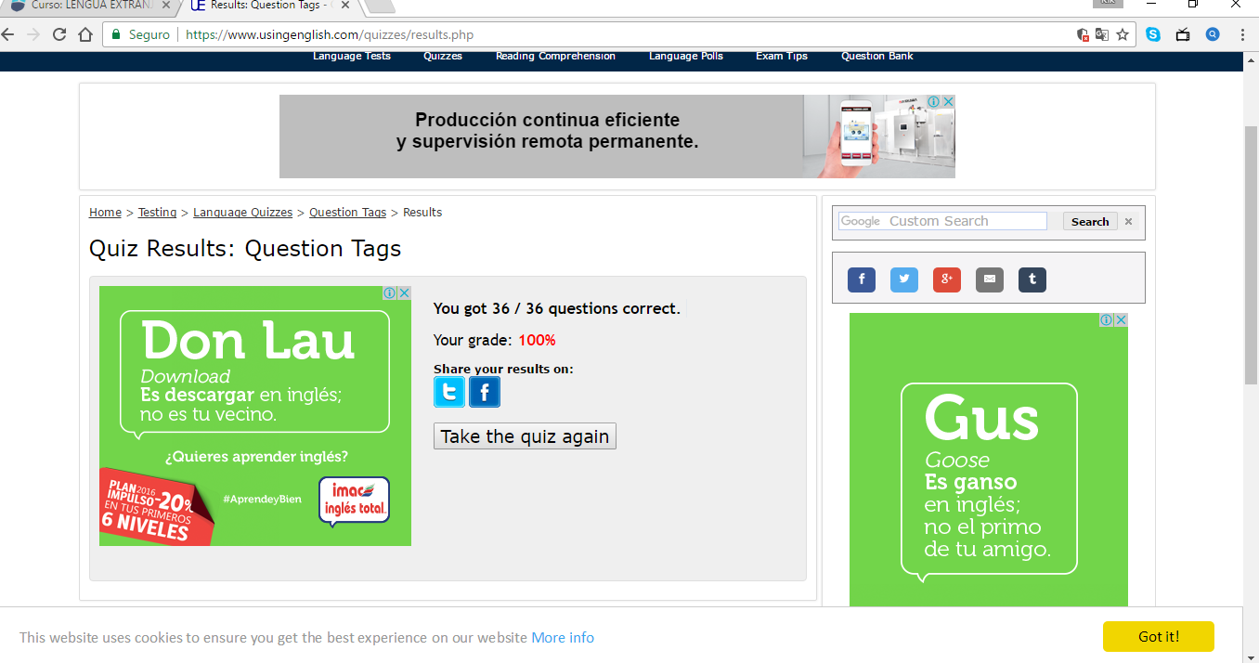
Cristina Velasco Navarro

