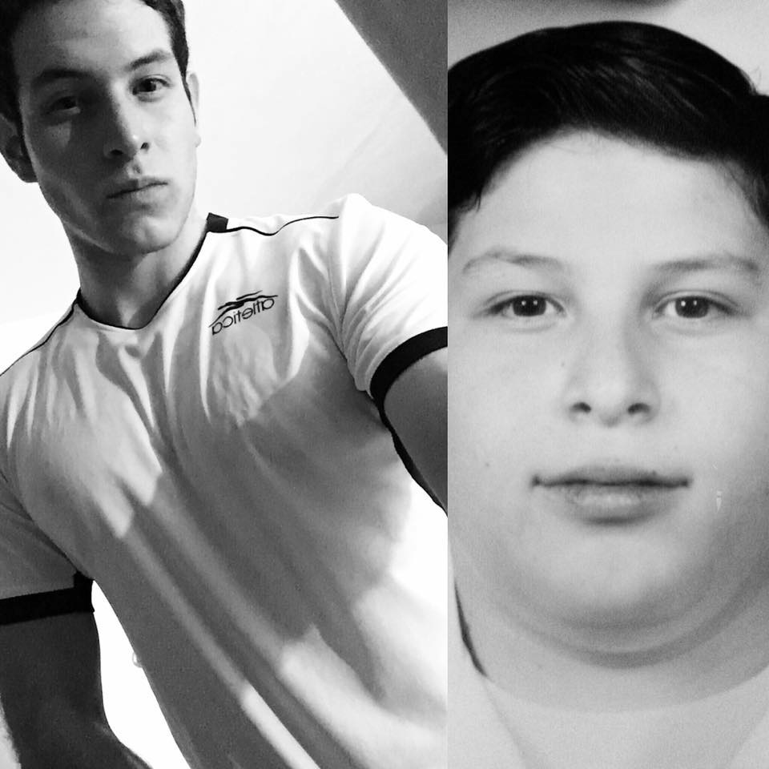
First name: Rodrigo
Last name: Melgoza
Age: 17 years old
Address: cruz verde #595
City: Guadalajara
Country: México
Suitable- house
Telephone: 3310113764
E-mail: rodrigoda2009@hotmail.com

ESTUDIES
AGE: 2015-2017
City: Guadalajara
Country: México
Institution: Lamar University
Languages: Spanish
English
Italian

WORK EXPERIENCE
May – Agoust 16 Company name: Personal trainer in freedom gym
Completed tasks: As a personal trainer

