Going to.
Friday, after of finish class, I going to eat in my home, then i going to see video in youtube of entertainment, by the end I going to do my homework of Blended Learning. After I going to read a book that they asked me that I should have read from a homework of the teacher Karina. When I will get tired I going to read other thing. I going to not go out, because i don´t want and I’m not interested in going out, when get the night I going to wait to that my mother get to home and then I going to go to sleep and I going to wait to my father.
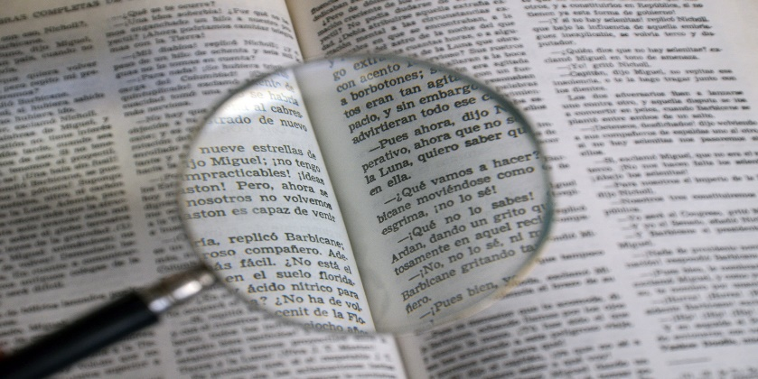
Saturday, I going to go out whit my mother, either out of the city or of my home, but us going to go. Then We going to seek where eat. After we going to return to home, provability I going to not I put to continue whit my homework of the teacher Karina, because I going to rest a little of the departure, and then I going to do my homework. From the rest of the day, I going to not much things.
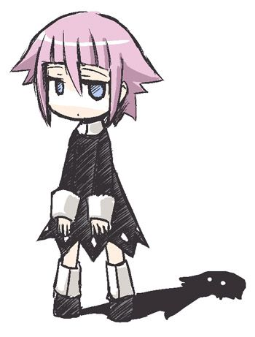

Sunday, I going to walk and run for the park in the morning. I going to put to draw and write my book, and I going to out to The square of the technology from that fix my cell phone decomposed, and too I going to do advance whit other homework that not is of the teacher Karina. I going to out whit friends from to clear me a little of the problems. After I going to Lead to a friend to her home and of there, I going to go to my home. Finality I going to be in my bedroom listen in music and picking up a little and wash my dirty clothes. Probability that in the night, I going to see a movie in my computer.

