Hour | Sartuday
9:00 -10:00 am | I’m going to have breakfast whit my family
10:00 – 11:00 am | I’m going to prepare for a party ( first communion)
2:00 – 4:00 pm | I’m going to eat whit my family
6:00 – 8:00 pm | I’m going home
9:00 – 11:00 pm | I will go to have dinner

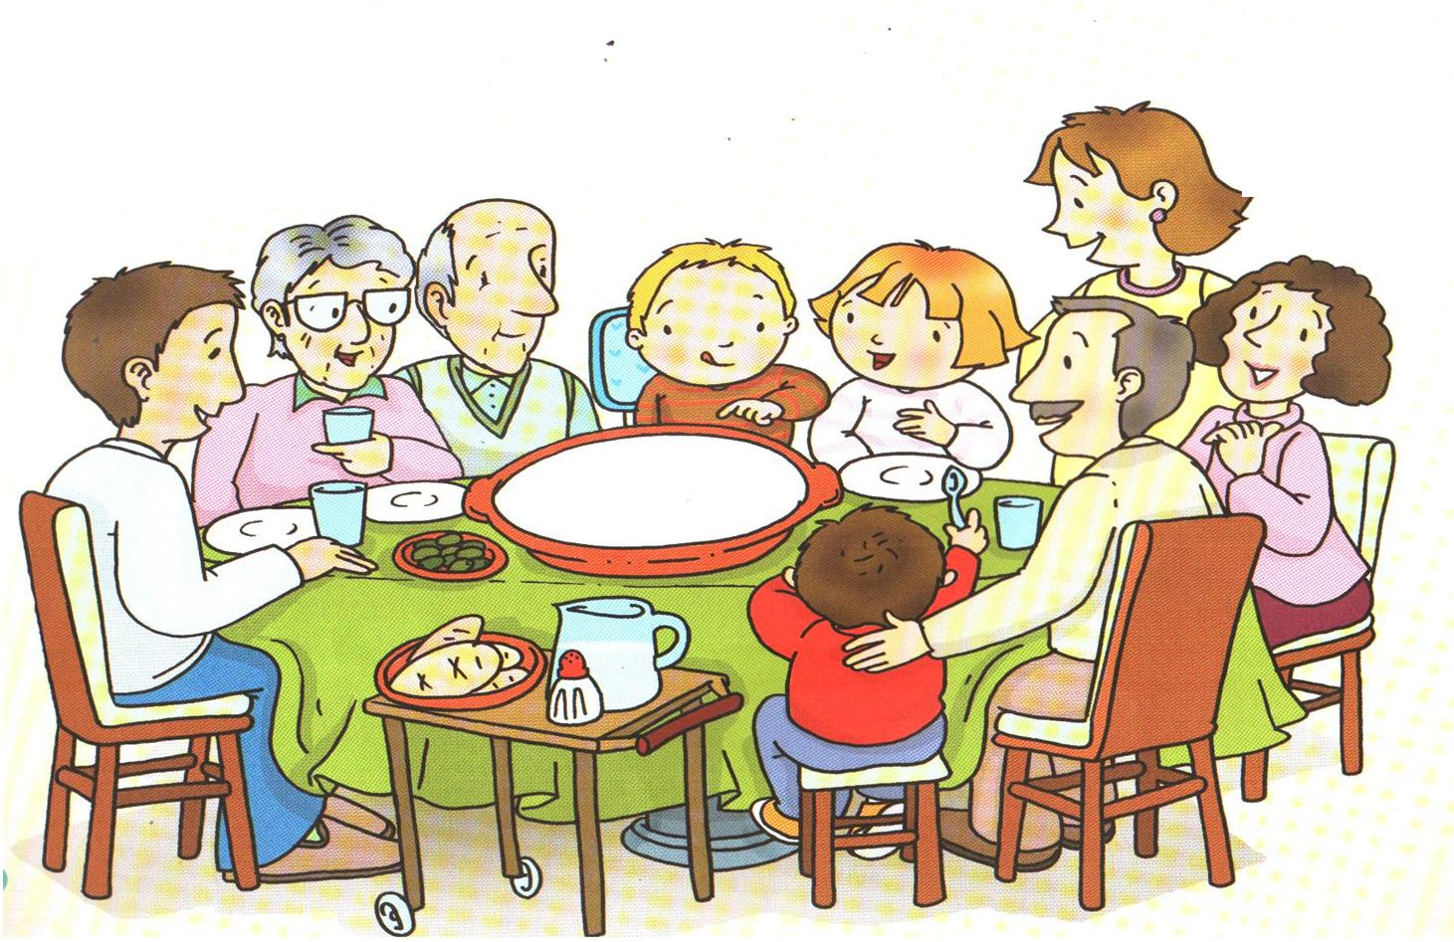

Hour | Sunday
10:00 – 11:00 am | I will have breakfast at my house with my family
1:00 – 3:00 pm | I’m going to eat whit my family in Chai
5:00 – 7:00 pm | I’m going home
8:00 – 11:00 pm | I’m going to watch movies

I will not go to the gym the weekend , I'm not going to accompany my mother to the dentist
The other weekend
Saturday morning breakfast in my house , I'm going to have lunch with my mom , and at night I went out to dinner with my boyfriend
Sunday I went to a party all day and came back at night to my house

