Page 26 and 27
What kind of jobs match your personality? Accountant, Bank clerk and factory worker.
Why? Because they are more office and not try almost people
What kind of jobs are not good matches for your personality? Teacher, designer and salesperson Why not? because you deal more with people , you try to please or look for customer needs
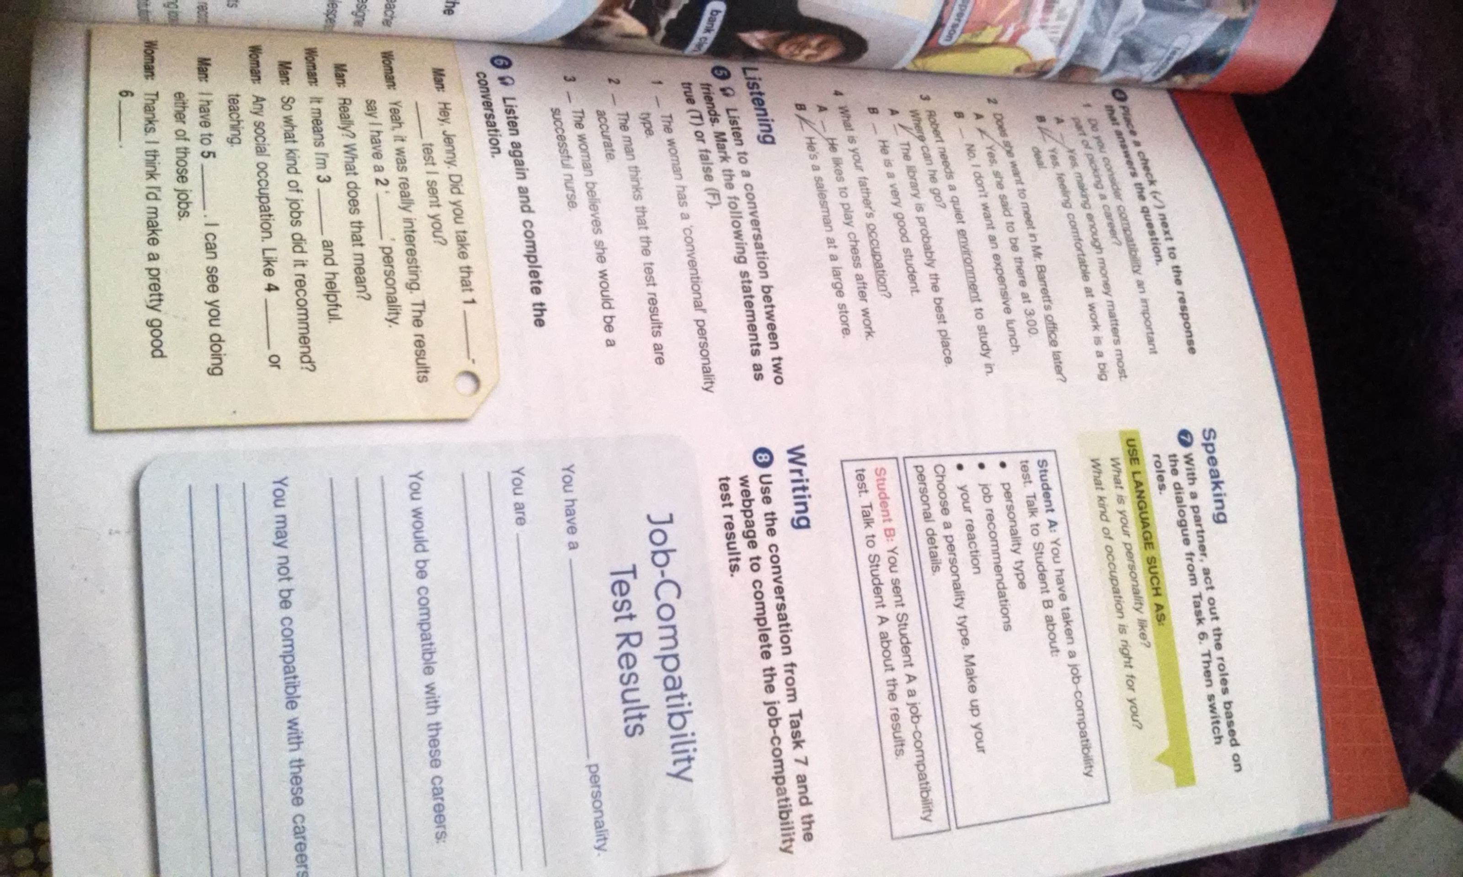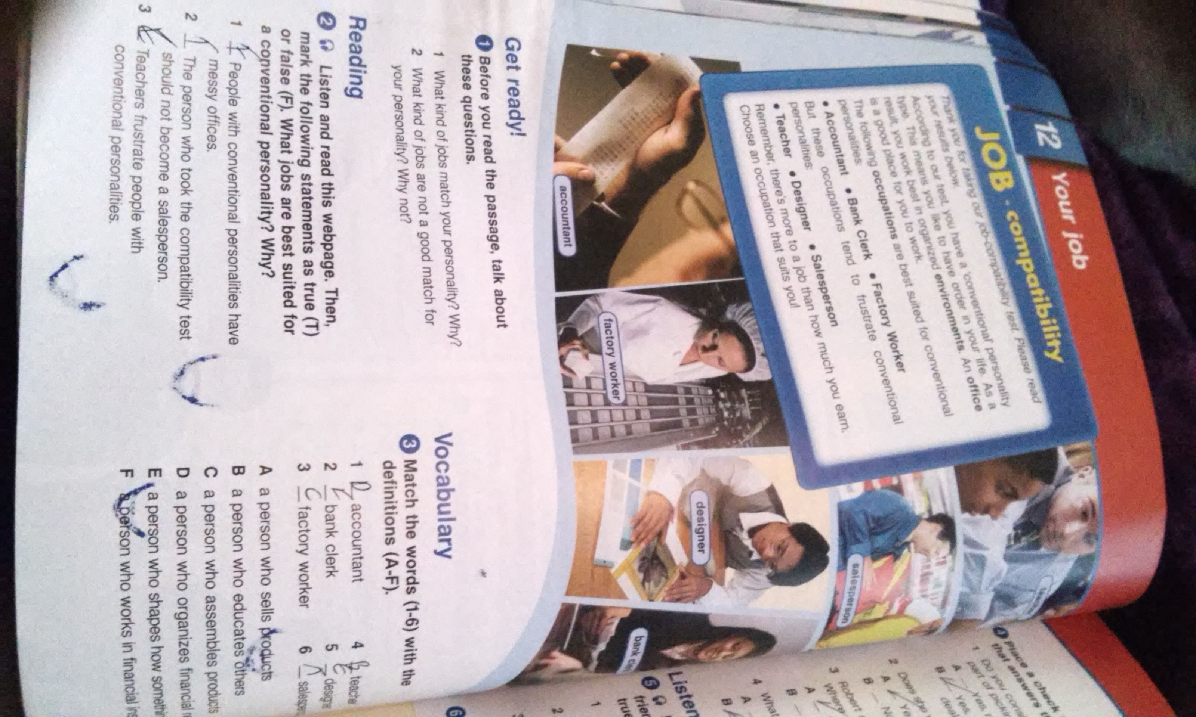

Page 28 and 29
When is it better to have a part-time job rather than a full-time job? It can be when you are studying or have another job or any other liability or at home.
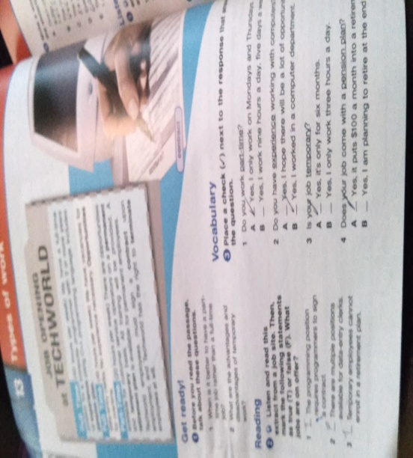
What are the advantages and disadvantages of temporary work? To adapt the work to the personal needs of the worker, enabling the reconciliation of work and family life
and the disadvantage is that there is more job rotation.
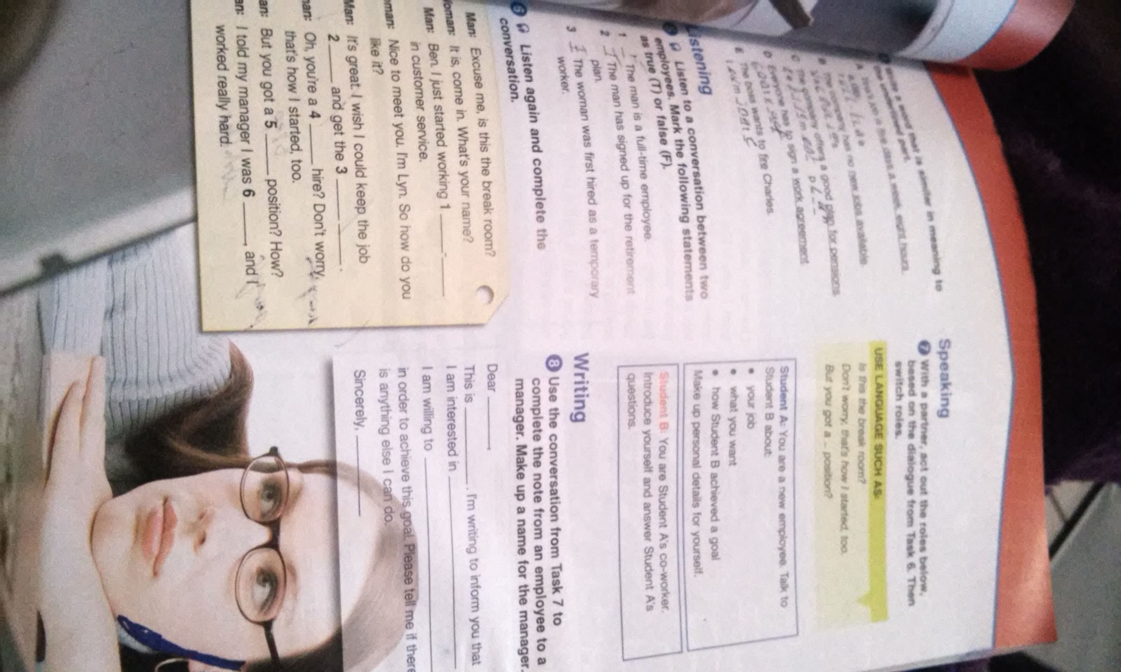

Page 30 and 31
How far would you be willing to travel every day to go to work? For if much need employment distance I think is not an impediment and all you can, you look for the easiest way to get to your job.
How do most people get to work where you like? Would look how to get to work wherever you like, so that you could get that job.
Does that system need to be improved? I think you should see more opportunities and if you can get your home close.
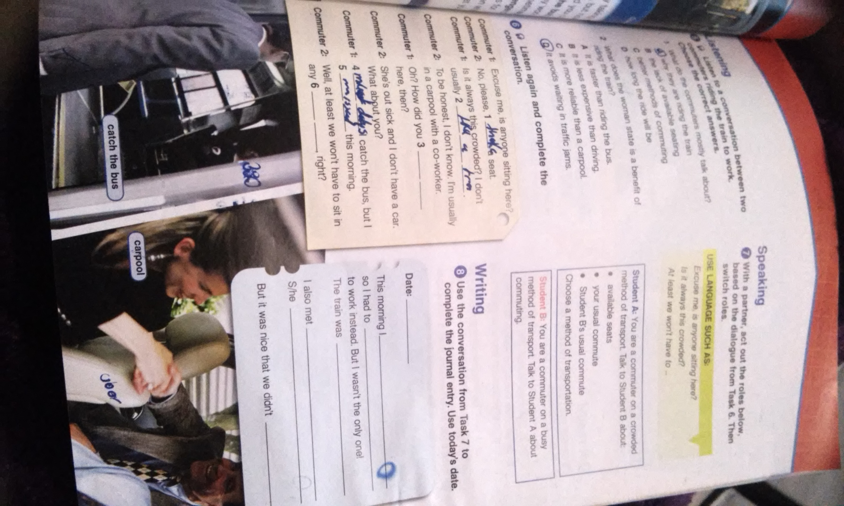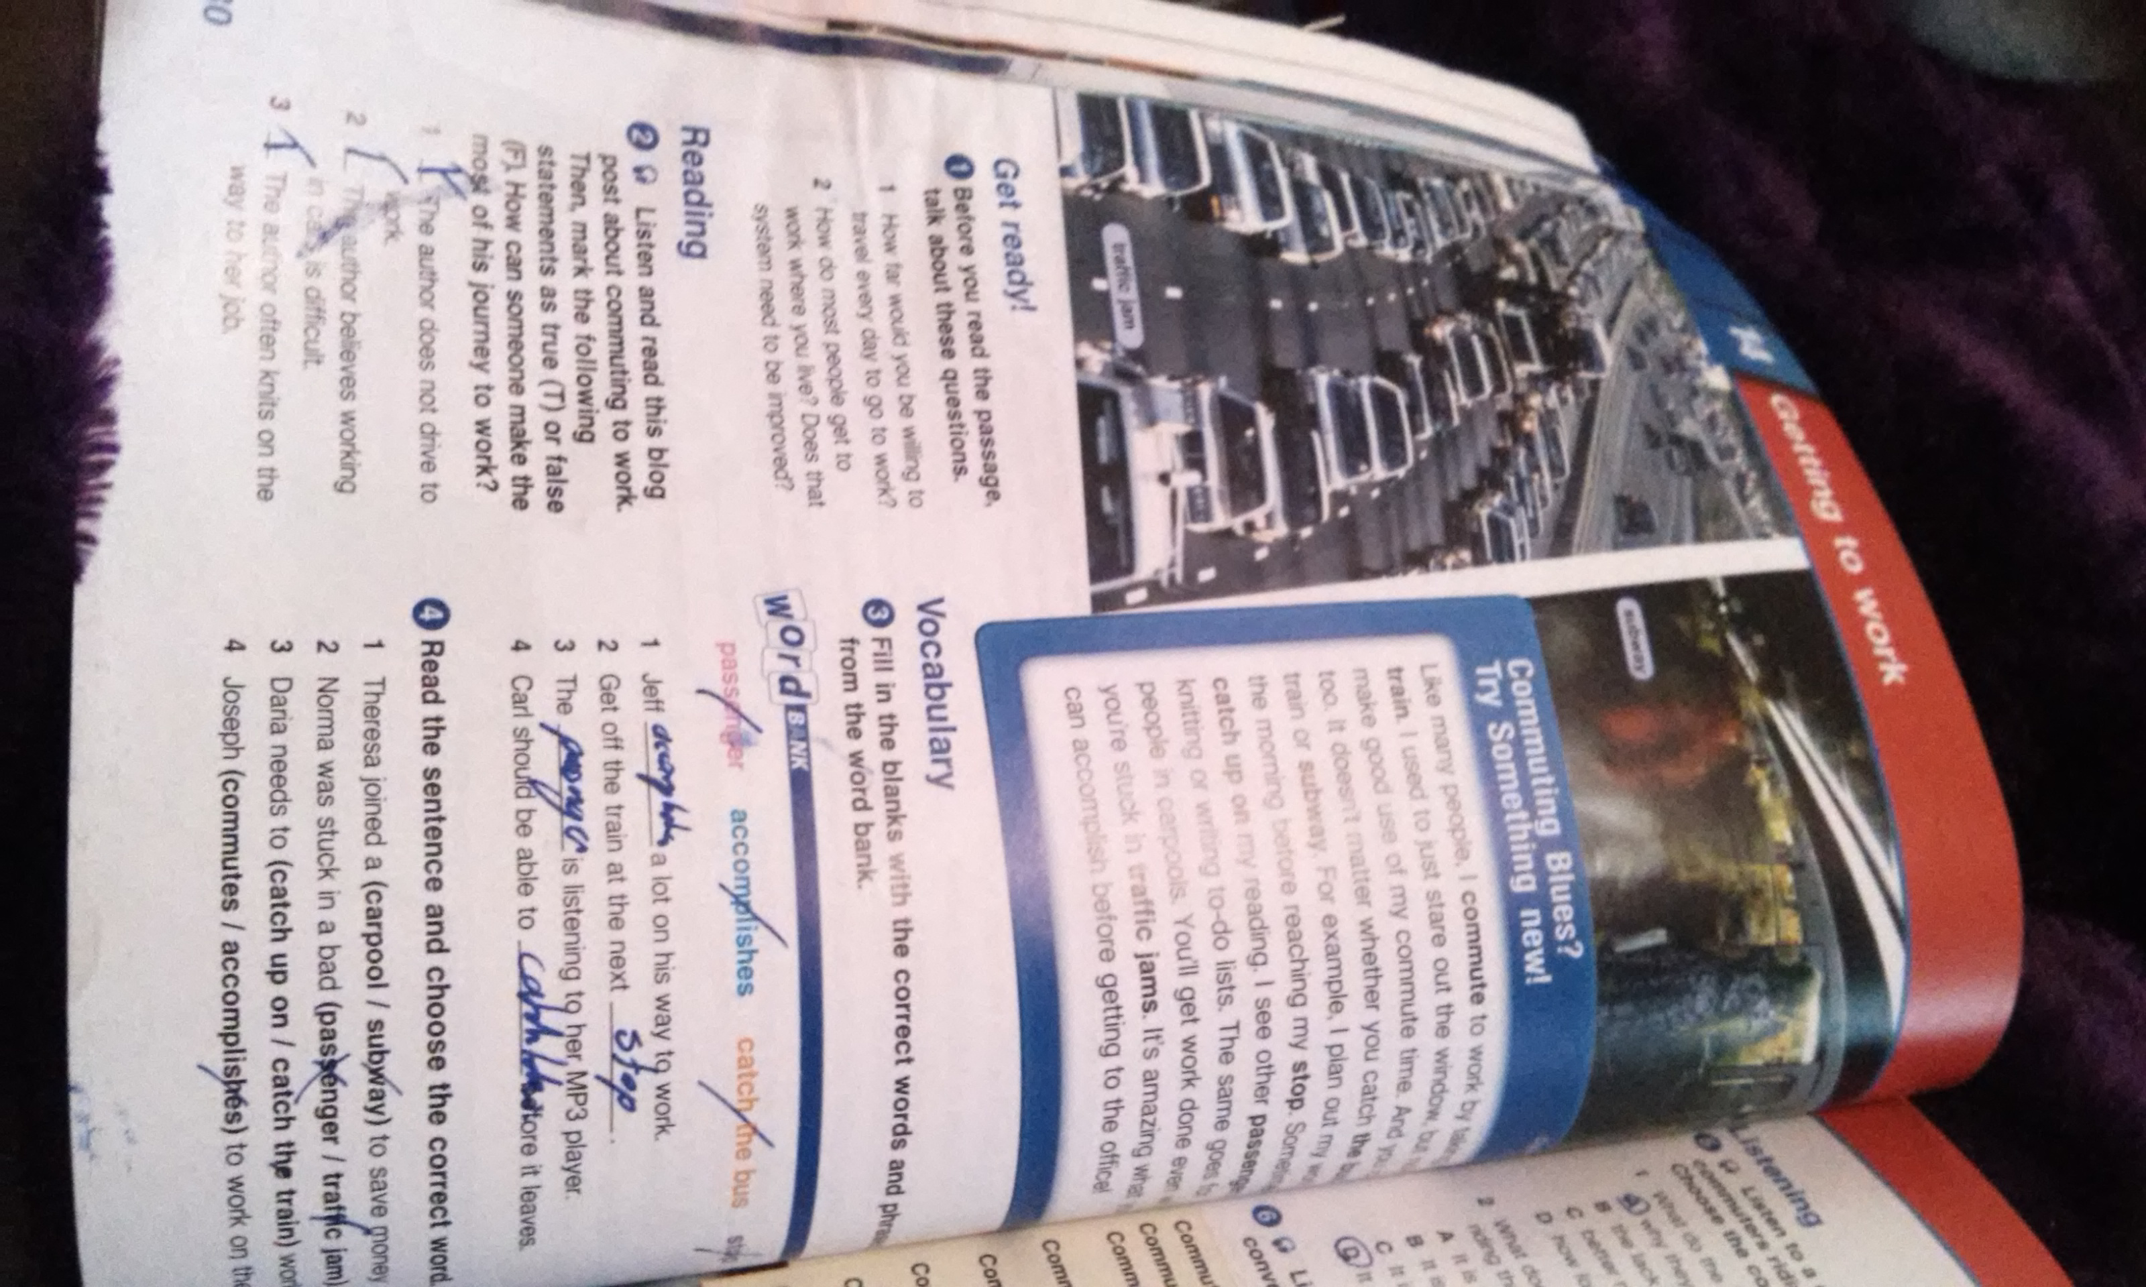

Page 32 and 33
Should jobs that require special skills pay more than unskilled jobs? Why or why not? because if you have the skills and are good at what the company calls you , I think if I should be paid more , but payment should be the same for everyone depending on the position.
Do you think that skilled workers work harder than unskilled works? Why or why not? Because sometimes if people are qualified to do their job and sometimes even more but may be the other way around.
