The article ¨an¨ it’s only used with vocals: a, e,i, o, u.
The article ¨a¨ is used with consonants.
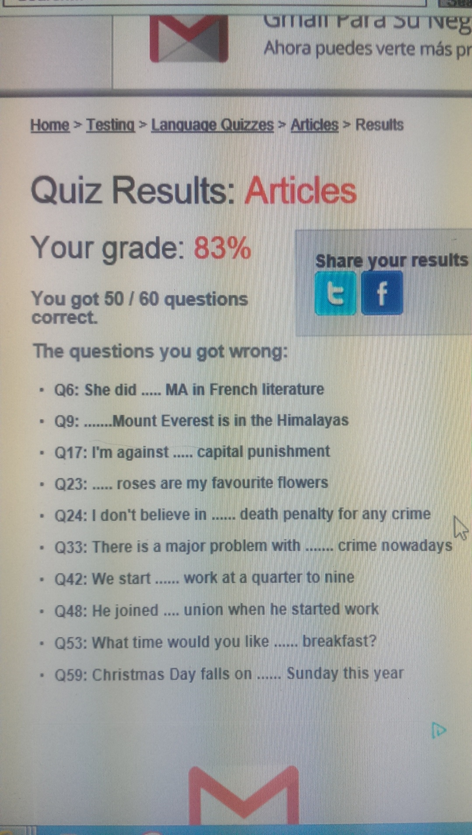
And ¨the¨ is used with Places and specific things.

