 | 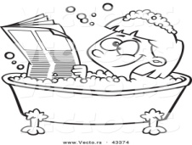 |  |  |  |  | 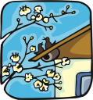 |  |  |  | 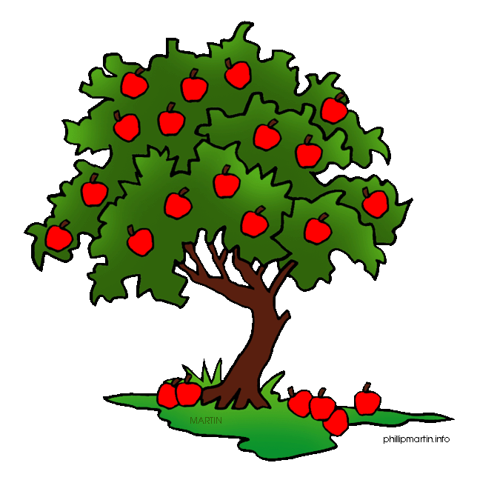
 | 1- | ____in______a bath |  |  | 2- | ___on____ a roof |  |  | 3- | _int__ a tree
 |  | 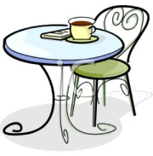 |  |  |  |  |  |  |  | 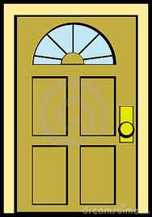
 | 4- | ____on_____ a table |  |  | 5- | ____in____ the office |  |  | 6- | ___at__ a door.
 |  | 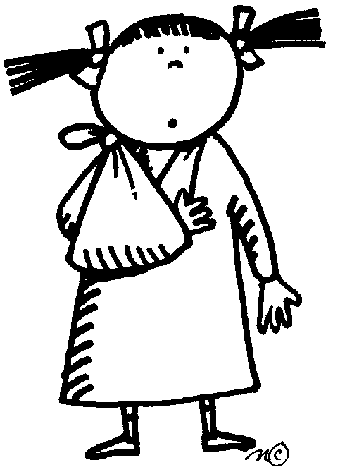
 |  |  |  |  |  | 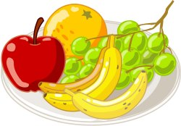
 | 7- | ___at___ her arm |  |  | 8- | ____on____ a plate |  |  | 9- | ____on____ your head
 |  |  |  |  | 10- | _in____a cup

