 | 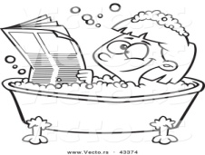 |  |  |  |  | 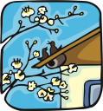 |  |  |  | 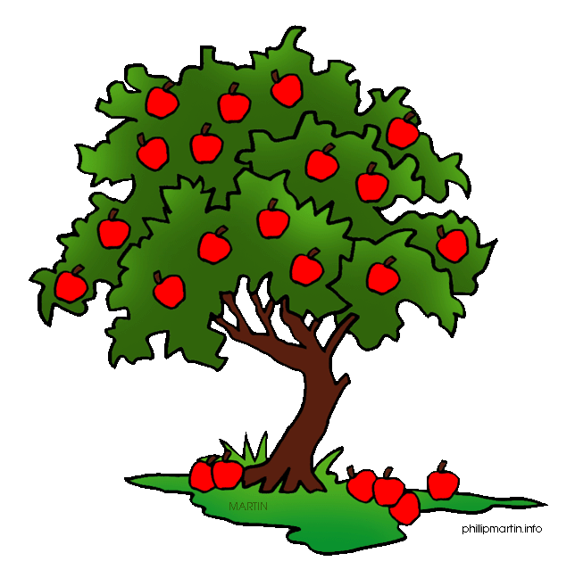
 | 1- | __IN________a bath |  |  | 2- | ___AT____ a roof |  |  | 3- | ___AT_____ a tree
 |  | 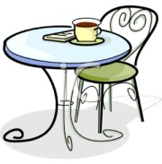 |  |  |  |  |  |  |  | 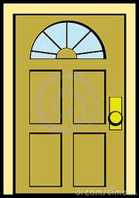
 | 4- | _____ON____ a table |  |  | 5- | ___IN_____ the office |  |  | 6- | __AT______ a door.
 |  | 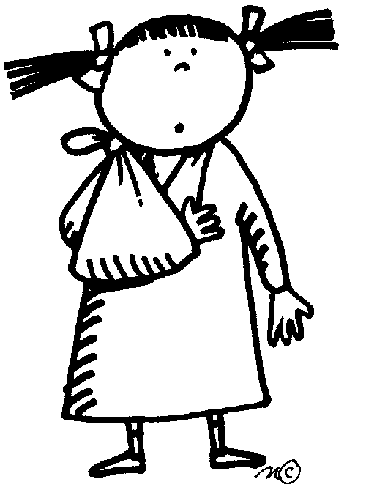
 |  |  |  |  |  | 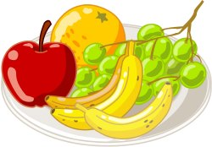
 | 7- | ___IN______ her arm |  |  | 8- | ____ON____ a plate |  |  | 9- | ____IN____ your head
 |  |  |  |  | 10- | ___IN_____a cup

