Armando Ruvalcaba Ortiz 2A

[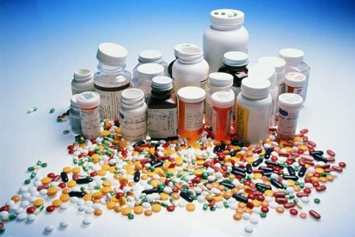](http://www.google.com.mx/url?sa=i&rct=j&q=&esrc=s&source=images&cd=&cad=rja&uact=8&ved=0ahUKEwi9puT4go3LAhUovYMKHZE1BTIQjRwIBw&url=http://www.musavision.com/medicinas-falsificadas-invaden-dominicana/&bvm=bv.114733917,d.amc&psig=AFQjCNGUVtsR97YjMAIUuZr8s483P2LBrA&ust=1456287254712519)[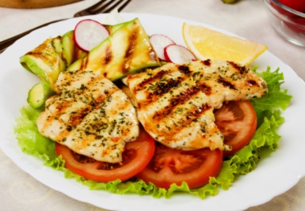](http://www.google.com.mx/url?sa=i&rct=j&q=&esrc=s&source=images&cd=&cad=rja&uact=8&ved=0ahUKEwi6xuKQgo3LAhUMuoMKHf2nCjoQjRwIBw&url=http://enforma.salud180.com/nutricion-y-ejercicio/10-consejos-para-preparar-comida-saludable&bvm=bv.114733917,d.amc&psig=AFQjCNHRdzFsBBy1WKxlo6o0g3VDXmsIcw&ust=1456287031396746)[](http://www.google.com.mx/url?sa=i&rct=j&q=&esrc=s&source=images&cd=&cad=rja&uact=8&ved=0ahUKEwjP4ZSfgY3LAhXHtoMKHW70DjEQjRwIBw&url=http://sp.depositphotos.com/11783711/stock-illustration-commanded-sign-safety-sign-pictogram.html&bvm=bv.114733917,d.amc&psig=AFQjCNHpwSyHxw5YHPZ-XCNZZs9NhgytqA&ust=1456286764677534)

Química genera seguridad vial. Química nos da alimentos nutritivos. Medicamentos.

Química en

[](http://www.google.com.mx/url?sa=i&rct=j&q=&esrc=s&source=images&cd=&cad=rja&uact=8&ved=0ahUKEwipuveThY3LAhVMtYMKHSsVDTMQjRwIBw&url=http://blog.incubadoradenegocios.com/casas-actuales-con-tres-recamaras/&bvm=bv.114733917,d.amc&psig=AFQjCNFh_k5ZTIFZPhni7Mqfb4EueFd4cQ&ust=1456287834387783)[](http://www.google.com.mx/url?sa=i&rct=j&q=&esrc=s&source=images&cd=&cad=rja&uact=8&ved=0ahUKEwiIv_zmhI3LAhVhl4MKHd90ADAQjRwIBw&url=http://www.chevrolet.com.pe/camaro-autos-deportivos.html&bvm=bv.114733917,d.amc&psig=AFQjCNHICl5X9k6jJit7mL7ttQQtg1eZig&ust=1456287750739329)[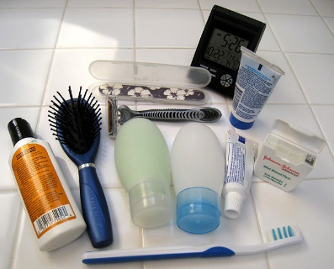](http://www.google.com.mx/url?sa=i&rct=j&q=&esrc=s&source=images&cd=&cad=rja&uact=8&ved=0ahUKEwjQsMaohI3LAhVHkoMKHQW8ADQQjRwIBw&url=http://es.wikihow.com/crear-un-empaque-con-art%C3%ADculos-de-aseo-para-viajar&bvm=bv.114733917,d.amc&psig=AFQjCNHvP3_05gbfiHNlTXXQKSsgw3EFQA&ust=1456287622937818) vida cotidiana