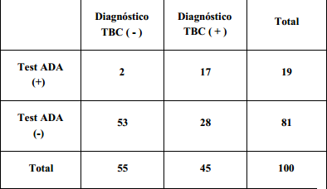
Diagnóstico de Pleuritis tuberculosa con ADA

S=17/(17+28) =0.377= 37.7%
E= 53/(28+53) = 0.654= 65.4%
VPP= 17/(17+2) = 0.894= 89.4%
VPH=53/(28+53) = 0.654= 65.4%
P= 19/100= 0.19= 19%

