MICHEL ALEJANDRO BURGOS RAMIREZ LME2363 30/10712

RR: Cie / Cio = a /a + b/c/c + d = .384 / .140 = 2.74
RA: Ie – Io = .384 - .140 = .24
RA %: RA /Ie x 100= .24 / .384 x 100 = 62.5%

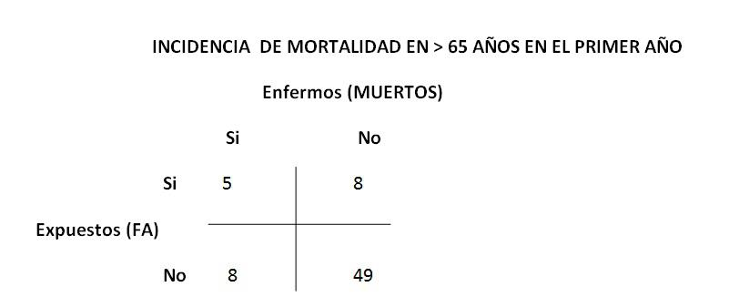

RR: Cie / Cio = a /a + b/c/c + d = .538 / .315 = 1.70
RA: Ie – Io = .538 -.315 = .223
RA %: RA /Ie x 100 = .223 /.538 x 100 = 41.4 %
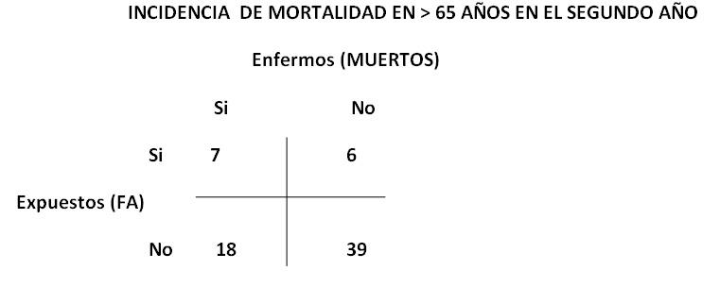

RR: Cie / Cio = a /a + b/c/c + d = .250 / .090 = 2.77
RA: Ie – Io = .250 - .090 = .16
RA %: RA /Ie x 100 = .16 / .250 x 100 = 64 %
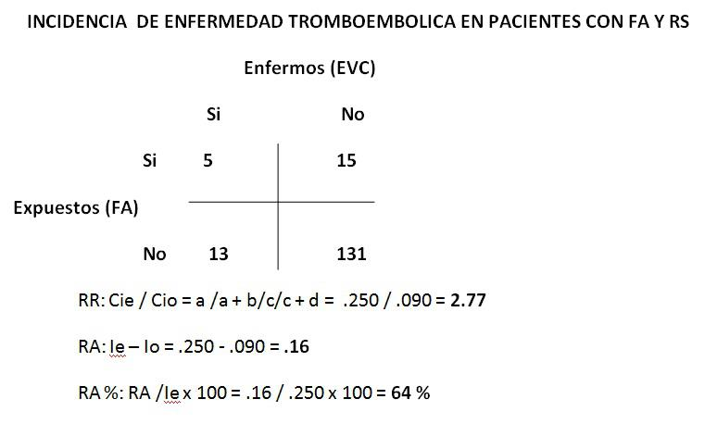

PACIENTES CON HTA
RR: Cie / Cio = a8 /a8 + b47/ c12/c12 + d97=1.27
RA: Ie – Io=0.03
RA %: RA /Ie x 100=21%

DM.
RR: Cie / Cio = a 3/a3 + b13/ c17/c17 + d131= .18 .11=1.63
RA: Ie – Io=.07
RA %: RA /Ie x 100= 38%

Dislipidemia;
RR: Cie / Cio = a /a + b/ c/c + d= .10 .11= 1.45
RA: Ie – Io= 0.05
RA %: RA /Ie x 100= 20%.
IAM;
RR: Cie / Cio = a2 /a2 + b10/ c18/c18 + d134= 1.45
RA: Ie – Io=0.05
RA %: RA /Ie x 100= 31%.
Varones;
RR: Cie / Cio = a /a + b/ c/c + d= 4.5
RA: Ie – Io= .14
RA %: RA /Ie x 100=77%

